Ministry of Science and Higher Education of the Republic of Kazakhstan
NJSC «L.N. Gumilyov Eurasian National University»

Inkara Suleimenova Almazovna

Development of a recommendation system for museum exhibits

The topic of the thesis

THESIS

«6В06103 – Information Systems» educational program

Ministry of Science and Higher Education of the Republic of Kazakhstan
NJSC «L.N. Gumilyov Eurasian National University»

«Admitted to the Defense»
«____» ________ 2026
Head of the Department
«Information System»

___________ A. A. Mukhanova

THESIS

topic: «Development of a recommendation system for museum exhibits»

«6В06103 Information Systems» educational program

Completed: Suleimenova I. A.

Research Supervisor
Candidate of Physical and
Mathematical Sciences, Associate Professor La L. L.

Ministry of Science and Higher Education of the Republic of Kazakhstan
NJSC «L.N. Gumilyov Eurasian National University»

Institute of Digital Technologies and Artificial Intelligence
Educational Program «6B06103 − Information Systems»
Department of «Information Systems»

Approved
Head of the Department
«Information System»
_________ Mukhanova A. A.
«_____» __________2026

ASSIGNMENT
for the Thesis (Final Year Project)

Student: Suleimenova Inkara Almazovna, 4th year, group IS-42, educational program «6B06103 – Information Systems», full-time study.
- Topic of the Final Year Project (Diploma Thesis) «Development of a recommendation system for museum exhibits»
approved by the Rector’s order dated «___»____2026 №_____
- Deadline for submission «___ »___ 20_
- Initial data for the project:
- Development of web applications using FastAPI and Streamlit;
- Use of the CLIP model for generating image embedding;
- Design and implementation of relational databases using PostgreSQL.
- Tasks to be addressed in the final project
- collection, analysis, and systematization of scientific and technical literature on recommendation systems and digital museum technologies;
- selection of appropriate methods for image processing, feature extraction, and recommendation generation;
- development and implementation of a recommendation algorithm based on visual similarity and user preferences;
- design of system architecture, including backend, database, and user interface;
- evaluation of system performance and formulation of conclusions.
- List of graphical materials
- presentation of the final project;
- 39 figures included in the thesis.
- Recommended literature:
- Ricci, F., Rokach, L., & Shapira, B. (2022). Recommender Systems Handbook.
- Consultations on the Project

Section (Chapter) | Scientific Supervisor / Consultant | Deadline | Assignment Issued (Signature) | Assignment Received (Signature)
Introduction | La L. L.
Chapter 1. The Role of Information Technologies | La L. L.
Chapter 2. Design and Development | La L. L.
Chapter 3. System Implementation | La L. L.
Conclusion | La L. L.
List of References | La L. L.

- Schedule for Completing the Final Year Project

№ | Development Stages | Timeline | Notes
1 | Approval of the thesis topic |  | Order No. 71-p
2 | Collection of materials for the thesis |  | Before internship
3 | Preparation of the theoretical part (Chapter 1) |  | Before internship
4 | Preparation of the analytical part (Chapters 2–3) |  | During internship
5 | Completion of the draft version of the thesis |  | During internship
6 | Submission of the thesis for pre-defense |  | After internship
7 | Submission of the thesis for review |  | After standard control
8 | Submission of the final version with supervisor’s feedback and review |  | After plagiarism check
9 | Defense of the thesis |  | According to the State Examination Commission schedule

Date of assignment issuance: «_____ »____________20___

Scientific Supervisor can. of phys.-math.sci., Associate Professor La L. L.
signature, full name, academic degree, position
Assignment accepted by: student Suleumenova I. A.
signature full name
Аннотация

Дипломная работа на тему «Разработка интеллектуальной рекомендательной системы для музейных экспонатов» состоит из 62 страницы и включает 39 рисунков. Работа посвящена проектированию и разработке рекомендательной системы, направленной на персонализацию пользовательского опыта в цифровой музейной среде. Особое внимание уделено использованию эмбеддингов изображений и методов машинного обучения для анализа визуальных характеристик произведений искусства. В ходе исследования были рассмотрены современные подходы в области рекомендательных систем и компьютерного зрения. Ключевой особенностью разработанной системы является использование модели CLIP для построения эмбеддингов и вычисления сходства между произведениями искусства, что позволяет формировать персонализированные и визуально релевантные рекомендации.

Аңдатпа

«Музей экспонаттарына арналған интеллектуалды ұсыныс жүйесін әзірлеу» тақырыбындағы дипломдық жұмыс 62 беттен тұрады және 39 суретті қамтиды. Жұмыс цифрлық музейлік ортада пайдаланушы тәжірибесін дербестендіруге бағытталған ұсыныс жүйесін жобалау мен әзірлеуге арналған. Ерекше назар өнер туындыларының визуалды сипаттамаларын талдау үшін кескін эмбеддингтерін және машиналық оқыту әдістерін қолдануға аударылған. Зерттеу барысында ұсыныс жүйелері мен компьютерлік көру саласындағы заманауи тәсілдер қарастырылды. Әзірленген жүйенің негізгі ерекшелігі – CLIP моделін пайдаланып эмбеддингтерді құру және өнер туындылары арасындағы ұқсастықты есептеу, бұл дербестендірілген және визуалды тұрғыдан релевантты ұсыныстар қалыптастыруға мүмкіндік береді.

Abstract

The diploma thesis titled «Development of an Intelligent Recommendation System for Museum Exhibits» consists of 62 pages and includes 39 figures. The work focuses on the design and development of a recommendation system aimed at personalizing the user experience in digital museum environments. Special attention is given to the use of image embeddings and machine learning methods for analyzing visual characteristics of artworks. During the study, modern approaches in recommender systems and computer vision were analyzed. A key feature of the developed system is the use of the CLIP model for generating embeddings and computing similarity between artworks, which enables the formation of personalized and visually relevant recommendations.

Table of Contents

 | Introduction………………………………………………………………………….. | 7
1 | The Role of Information Technologies in Enhancing User Experience in Museums…………………………………………………………………………….. | 9
1.1 | Digital Transformation of Museums: Impact on Visitor Experience and Accessibility of Cultural Content…………………………………………………..... | 9
1.2 | Modern approaches to building recommendation systems in the museum field……. | 10
1.3 | Analysis of existing solutions……………………………………………………….. | 11
2 | Architecture and structure of the web application…………………………………... | 15
2.1 | Dataset selection and analysis……………………………………………………….. | 15
2.2 | Data preparation and processing…………………………………………………….. | 18
2.3 | Image embedding and image similarity assessment methods……………………….. | 20
2.4 | Recommendation Generation Algorithm……………………………………………. | 23
2.5 | Database structure………………………………………………………………….... | 28
2.6 | Web Application Architecture………………………………………………………. | 30
3 | Recommendation system design and implementation………………………………. | 35
3.1 | Physical modeling of a database for storing museum information………………….. | 35
3.2 | Implementation of the recommendation algorithm………………………………….. | 39
3.3 | Backend implementation…………………………………………………………….. | 45
3.4 | User Interface Implementation……………………………………………………..... | 49
 | Conclusion…………………………………………………………………………… | 57
 | List of Reference…………………………………………………………………….. | 59
 | Appendix…………………………………………………………………………….. | 61

Introduction

In today’s life, museums are considered to be one of the most valuable attractions that keep alive the history and culture of humanity. Museums make a significant contribution to preserving the cultural heritage of the nation. However, the more exhibits and data provided by the museum, the more frequently museum fatigue is encountered. The term “Museum fatigue” is attributed to Benjamin Ives Gilman who proposed it at the beginning of the twentieth century. It should be noted that a visitor loses interest in what he/she sees in the museum, and he or she simply gets tired while staying there for a very long time. As a result, a visitor begins to move faster in the museum halls, ignoring the explanation of the exhibit, and, accordingly, obtains no benefit from user visit.
In one of the most recent studies performed by Claudio Zavattaro and others, it was found out that this issue remains actual and requires further solving [1]. Due to the mentioned factor, an increased interest appeared in intelligent systems that would be able to make the visit to a museum personalized for each visitor and would facilitate the process of navigating through different works of art. Recommendation system development, considering user preference and behavioral characteristics, seems like a prospective way to solve this issue. The application of computer vision and machine learning technologies considerably contributes to this issue since they allow analyzing different features of artworks and recommending those which would fit users' preferences.
Indeed, many museums are already implementing the mentioned innovations in order to increase users' involvement in their activities. In particular, it is known that usage of digital and interactive technology helps to develop passion and enhances the information reception process [4]. Thus, according to recent findings, the usage of recommendation algorithms in digital museums is able to enhance visitors' navigation, make information more relevant and also increase visitors' interest in the museum activities [5]. Also, it should be noted that modern approaches involve the consideration not only of user behavior, but also the context of this interaction.
This final project will present an approach to creating an intelligent recommendation system for museum exhibitions. It was assumed that this museum recommendation system could play the role of a virtual museum assistant, helping visitors find the works of art they like, as well as increasing interest in visiting the museum. To develop such recommendations, the visual similarity between different works of art, the interaction of users with them, and the grouping of art objects were studied.
The significance of the research may be explained by several arguments. In modern times, museums are gradually transforming into digitized spaces, which makes it possible to implement innovative technologies like AI and recommendations systems[3]. In addition to the issue of museum fatigue, there is a necessity for solutions that could assist users in visiting museums more efficiently and making their experiences enjoyable[4]. The application of image analysis techniques like image embedding creates new opportunities to learn about people’s taste in art and provide more effective recommendations.
Practical importance of this research work consists in creation of system able to raise interest in visiting museums. Such a system will be able to concentrate attention of people to such exhibits that correspond to their interests, avoid information overloading and help to get more from visits to museums. Moreover, it will help to get a better understanding of visitors' preferences and present museum exhibits accordingly[2].
Main purpose of this research work is development of an intelligent recommendation system for exhibits of museums based on similarities between pictures.
In order to fulfill the goals stated above, we will be implementing the following objectives:
1. To conduct an analysis of the existing recommendation systems and their use in the context of culture and museums;
2. To study the concept of museum fatigue and its influence on museum visitors;
3. To design the architecture of the recommendation system based on the needs of scalability and usability;
4. To implement techniques that will allow us to identify visual features of the artworks using computer vision models such as CLIP, ResNet.
5. To design an algorithm that will generate personalized recommendations according to visual similarities;
6. To test the efficiency of the proposed system in terms of engagement increase.
In this case, the topic of this project can be described in relation to developing intelligent recommendations systems for exposition in the museum. It should be noted that this project takes into account two spheres of knowledge: the creation of software and analysis of the user's behavior.

The Role of Information Technologies in Enhancing User Experience in Museums

Digital Transformation of Museums: Impact on Visitor Experience and Accessibility of Cultural Content
There is a growing trend of implementing the use of digital technology in museums. It is caused by the struggle for visitors' attention and the necessity to stay relevant. The competition is growing as users have more opportunities to choose what form of leisure they want, including digital entertainment. Thus, museums need to develop novel strategies to engage their audiences. Under such circumstances, the user experience plays a pivotal role, which becomes a crucial element of survival for museum organizations. Today, museums are not only venues where one gets acquainted with the exposition passively but also become digital cultural platforms that aim at attracting their audience effectively. For this reason, museums apply different digital tools aimed at increasing accessibility, interactivity, personalization, and attractiveness of cultural content[17].
In accordance with the proposals of the International Council of Museums (ICOM), today’s museums have to perform not only a preserving function in relation to cultural heritage, but also increase the accessibility for visitors [4]. In turn, this is now becoming possible owing to modern technologies. The creation of various collections in the Internet, virtual tours, mobile applications, and navigational systems allows visitors to interact with museum expositions independently and conveniently. It also provides visitors with a possibility to get acquainted with the collection in advance and plan their visits.
Museums are also being revolutionized by innovations. It is clear from scientific studies that using digital technologies in museum activities leads to increased visitor satisfaction, improved perception of information, and emotional attachment [3]. This is especially important when it comes to the use of multimedia and augmented reality. This makes the exhibition more engaging and customized for every person.
Among other benefits of digitizing museums, one can single out the mass distribution of cultural material, which makes it possible to access information more widely. With the help of the Internet and technologies, people can visit museum expositions regardless of their geographical location. Access to art work through Internet, as well as archives and databases, increases the number of people visiting museums [19].
Another strength of digital technology is the possibility to pay attention to individual features of information processing by certain groups of consumers. Interactive systems are able to generate material according to the educational level of the user, user preferences or interests. It plays an especially significant role when speaking about the diversity of museum audiences [18]. The fact is that this approach will not cause fatigue due to a prolonged viewing session, since all the information provided appeals to him.
Data analysis and artificial intelligence solutions are crucial tools in the digital transformation process. They enable you to gather data on the behavior of users and use it to determine their preferences, making personalized suggestions based on this [9][10]. This helps create intelligent assistants that would guide the visitor through their interaction with the exhibit[5].
The digital transformation of museums is a decisive point in terms of improving the user experience and increasing the accessibility of cultural products. Thanks to the implementation of innovative technologies, it becomes possible not only to update classical methods of exhibiting the objects but also to invent new forms of interaction between users and cultural heritage.

Modern approaches to building recommendation systems in the museum field
Recommendation systems are crucial in terms of personalization of content. The goal of the recommender systems is to provide a particular user with the information that he or she needs, depending on his or her preferences, behavior, and object features. Recommender systems are primarily applied in such spheres as online shopping, streaming, and social networks, and they help users spend more time using the website[12].
As per the findings from Francesco Ricci, Lior Rokach, and Bracha Shapira, recommendation systems may be categorized into a number of major categories: collaborative, content-based, and hybrid recommendations[10]. Collaborative recommendation systems are founded upon analysis of user activities and discovery of similarity in preferences, whereas content-based recommendation systems depend upon features of items in order to make recommendations[5].
There are several unique aspects associated with recommendation systems in the museum industry. In contrast to regular digital services, where a person deals primarily with textual or multimedia content, the visual perception of an object is important in the museum industry. Moreover, users do not always have any clear preferences concerning art, which makes it difficult for the system to provide personalized recommendations. This situation results in the "cold start" phenomenon, meaning that there is not enough information about the user to give him/her recommendations[16].
Modern studies prove that recommendation systems in the digital museum environment assist in navigation and enable visitors to plan their route within the museum[7]. In particular, it is crucial that when receiving recommendations tailored specifically to an individual user, they can discover the exhibits they are interested in. Recommendation systems mitigate the influence of museum fatigue on the visitor by optimizing the information flow [1][2].
Currently, special emphasis is being made on the application of artificial intelligence technologies in recommendation systems. The application of machine learning algorithms makes it possible not only to take into account the explicit user preferences but also the implicit ones reflected in his behavior [8][9]. This approach makes it possible to create a more accurate and flexible system of recommendations. For example, context-dependent recommendation systems are able to consider such factors as the current condition of a user and his activities in the system[5].
Among those, one particularly exciting field is computer vision, which provides means for examining visual properties of artworks. By contrast with classical solutions, based on metadata, the approach lets you include color, style, and other visual features. Applying modern models, such as CLIP, invented by Alec Radford et al., and ResNet, designed by Kaiming He, you can transform images into vectors and measure the level of their similarity [20][21]. Thanks to this feature, there appears an extra possibility to make recommendations based on visual similarity of artworks.
The current techniques also include clustering of exhibitions according to styles, genres, or visual characteristics. The purpose of such clustering is to make it easier for you to find useful information in the database. It becomes much easier for you to do so if the collection you are dealing with is quite extensive [8].
Recommendation systems will allow users to visit museums with ease and excitement. They personalize the material for each individual, optimize navigation, and alleviate the tiredness associated with excessive amounts of information. With the use of artificial intelligence and computer vision technologies, the opportunity arises to build intelligent systems that consider not only the behavior of the users but also the visual characteristics of artworks. Recommendation systems become a very promising area for the further development of digital technologies in museums.

Analysis of existing solutions
Owing to the fast growth of technologies in digital space and increased amounts of accessible content, the current market particularly appreciates the creation of personalized systems. Recommendations are often utilized in different areas such as online stores, streaming, and social media. The study of already existing recommendations enables identifying strengths and weaknesses in their operation as well as further ways of creating more effective recommendations for museums [8][9].
Perhaps the most popular recommendation systems are streaming websites like Netflix and Spotify. These systems utilize advanced machine learning models that take into consideration the data analysis of user's behavior and preferences. Recommendations are done through a combination of collaborative filtering methods along with content analysis methods [12][13]. The key benefits of these recommendation systems include highly accurate recommendations along with the adaptation capabilities in line with user interest. The drawback of these systems lies in the fact that they are mostly limited to textual and audiovisual content, without any regard for visual arts.
In addition, there are various internet resources in the museum industry designed for providing greater accessibility to cultural content. For example, one of the most popular websites is Google Arts & Culture which offers access to the world's leading museum collections, presented in Figure 1 below. It gives an opportunity to get acquainted with artistic masterpieces, to visit virtual expositions, and obtain information on exhibitions [26]. However, despite the excellent design of the site, its interface and great visualization, the opportunities to customize search results remain limited.

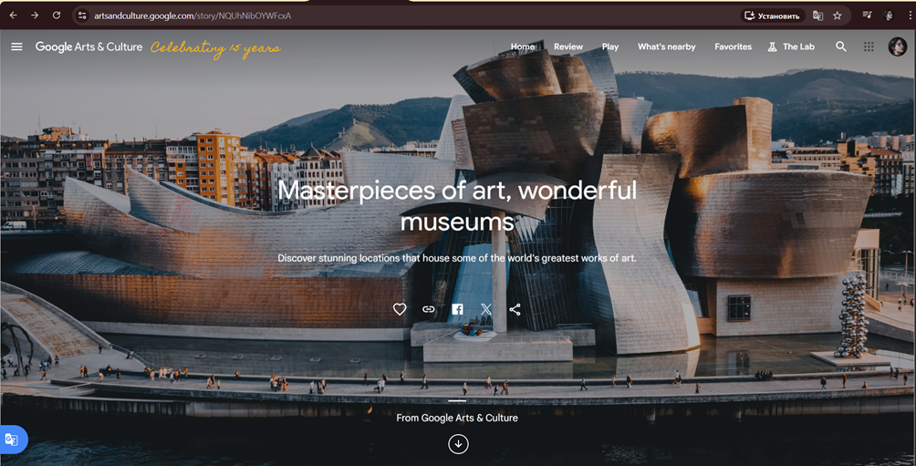

Figure 1 – The interface of Google Arts & Culture

An example of such an app is the Smartify application for smartphones, which allows recognizing paintings with a phone camera and viewing their description, see Figure 2. Such an app is based on computer vision techniques and represents a very useful instrument for communicating with museum exhibits. In turn, its main drawback is that it does not make any personal recommendations.



Figure 2 – The interface of Smartify

Special consideration must be given to the digital transformation of large museums, like the Metropolitan Museum of Art and the Rijksmuseum, illustrated in Figures 4.

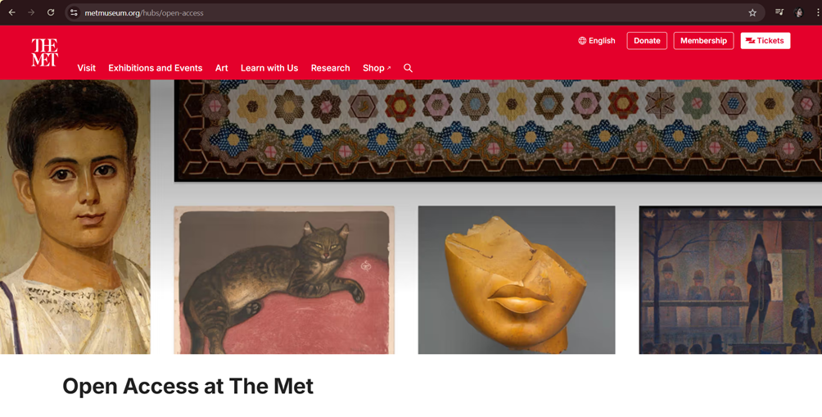

Figure 3 – The interface of Metropolitan Museum of Art

Such museums offer virtual tours, allowing visitors to explore their collections via high-resolution images and information about each item. For instance, the website of the Rijksmuseum allows users to form their collections according to certain categories and analyze artworks belonging to them, Figure 4. Nevertheless, the degree of personalization remains low; recommendations are mostly provided on the basis of predefined categories [27][28].

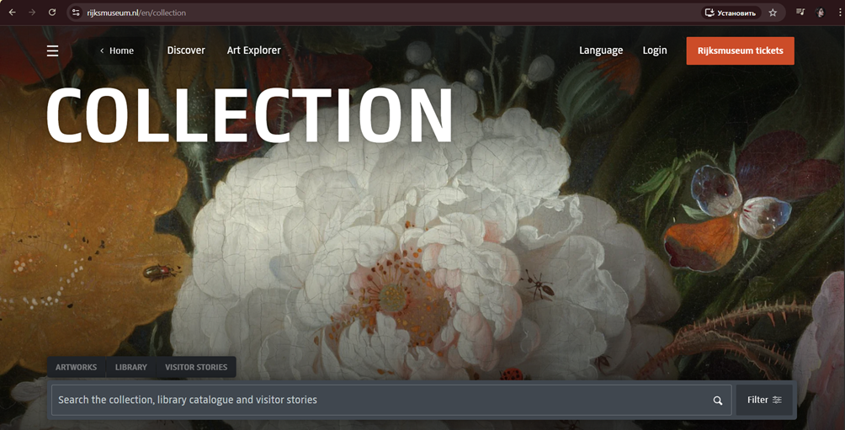

Figure 4 – The interface of Rijksmuseum

Existing solutions’ analysis proves that current systems can be classified as systems designed for sharing cultural content or systems which have minimum capabilities for communication with exhibit, Table 1. However, the complete personalization considering specific individual vision of the user is not provided properly yet. This concerns especially application of computer vision methods for analysis of artistic features of artworks [21][22].

Table 1 – Comparison of existing solutions

Criteria | Google Arts & Culture | Smartify | Metropolitan Museum of Art | Rijksmuseum
System Type | Web platform | Mobile application | Museum website | Museum website
Main Function | Collection browsing, virtual tours | Artwork recognition | Online collection | Online collection
Personalization | Limited | Minimal | None / weak | Limited
Recommendation Systems | Basic (similar artworks) | Almost none | None | Partial (category-based)
Use of AI | Partial | Yes (image recognition) | Minimal | Minimal
Interest-based Navigation | Limited | None | None | Limited
User Collection Creation | Yes | No | Yes | Yes
Main Limitation | Lack of deep personalization | Lack of recommendation features | Lack of personalization | Lack of AI-based recommendations

In contrast to other approaches, the one presented in this paper relies on applying machine learning and computer vision techniques for recommendation generation, which increases their precision [20][23]. Thus, the need for such a solution becomes quite evident against the backdrop of digitalization of the museum business segment. It becomes evident that a solution needs to be found in terms of developing intelligent recommendation systems capable of taking into account both behavioral and visual data.

Architecture and structure of the web application

Dataset selection and analysis
One of the essential steps in designing a recommendation system is the choice of a database, from which training and recommendations will be conducted. If an intelligent assistant for a museum is being created, there are specific demands regarding the choice of data that should be used for building recommendations – not only the pictures of the artworks should be provided, but also their structural description including information regarding the style, genre, and artist [10].
Initially, there were various sources of information that were considered, including museum databases such as The Rijksmuseum and The Metropolitan Museum of Art, Figure 5 [29]. One benefit of using these data sources lies in the possibility of getting high-quality images and meta-data due to the availability of the API. However, while analyzing these sources, it was discovered that there were some limitations in utilizing the data sets, particularly The Rijksmuseum database, which lacks any pre-compiled database but requires gradual assembling.

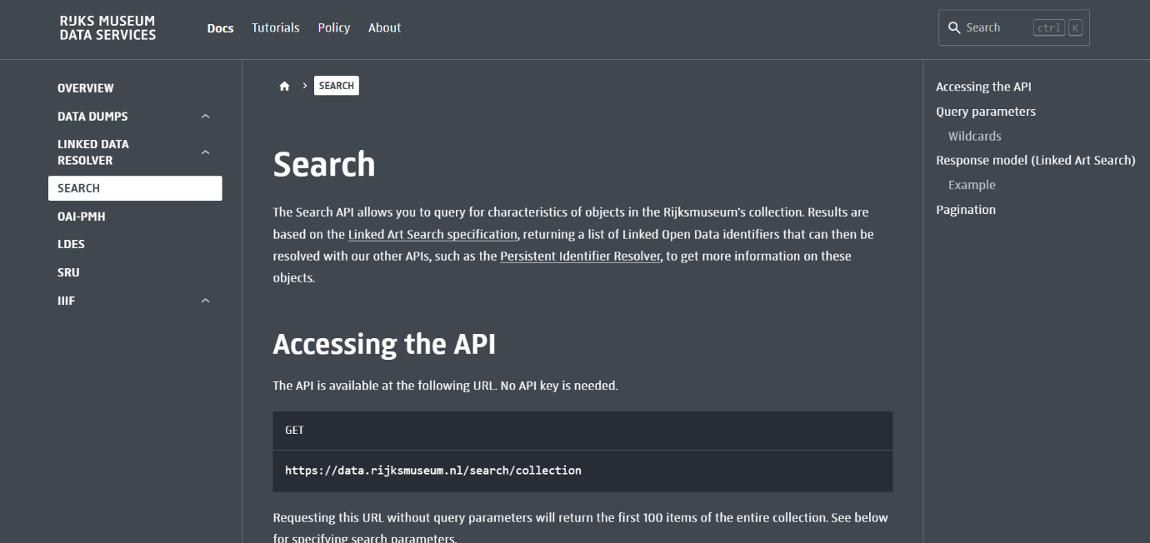

Figure 5 – API of Rijksmuseum

Later, a user-generated dataset using the Rijksmuseum collection became available on the Kaggle website, see Figure 6 below. The dataset was created by User Luis moneda who preprocessed and sorted the images into appropriate categories [29]. While developing the recommender system initially, the use of this very dataset was predominant. Nevertheless, it had one major drawback – there were only four categories of objects included in the database: drawings, paintings, photographs and photomechanical prints. It is far too few for creating diverse recommendations. Indeed, the system would provide suggestions from these very narrow categories ignoring the aspect of customization.
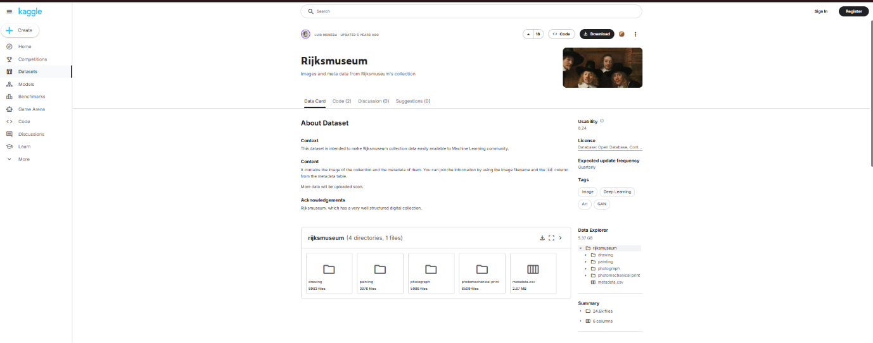

Figure 6 – The Rijksmuseum dataset on Kaggle

WikiArt was used as the principal data set – an extensive repository of artwork pictures categorized according to artistic styles, genre and artist, Figure 7 [30]. The major benefit of WikiArt lies in the fact that it describes all styles very thoroughly and clearly: there are dozens of artistic styles described, ranging from realism to cubism and abstract expressionism, and this gives many opportunities to find interesting things to offer. Moreover, all the images in the dataset are divided into styles and artists' directories, making the downloading and preparing work easier.

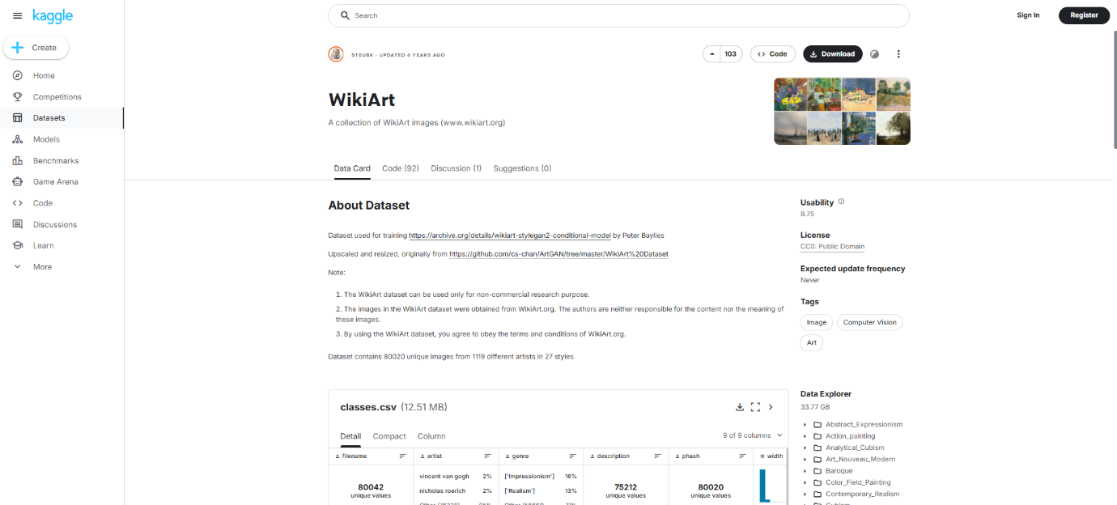

Figure 7 – Wikiart dataset on Kaggle

However, despite the powerful and promising data set, the use of WikiArt has its own characteristics. First, the size of the data set is rather large (from tens to hundreds of gigabytes), and using it on the laptop might cause a certain workload. Another important aspect is the imbalance of the dataset – when considering Impressionism, for example, one would come across thousands of paintings while in some other styles there may be just several dozen pieces. This fact might affect the preferences of the model and thus make it better at offering artworks belonging to popular styles but poor at finding anything rare [8].
WikiArt has been selected because of its availability and because of the structured nature of its metadata, and also because it can be used for visual analysis of art objects. However, further processing of the data is needed for the proper functioning of the system to achieve balance in the sample.
Another critical aspect when selecting a dataset is its potential compatibility with computer vision approaches. Whereas with most of the datasets obtained from museum APIs, the data is provided in the form of texts and various images, the data from WikiArt was initially created with the visual approach in mind, see Figure 8. As a result, such a dataset is perfect to be applied with the machine learning techniques to analyze semantic features of images. In addition, due to the presence of directory structure and images being connected to certain artistic styles (filename field), you can use the dataset to develop a visual recommendation system.

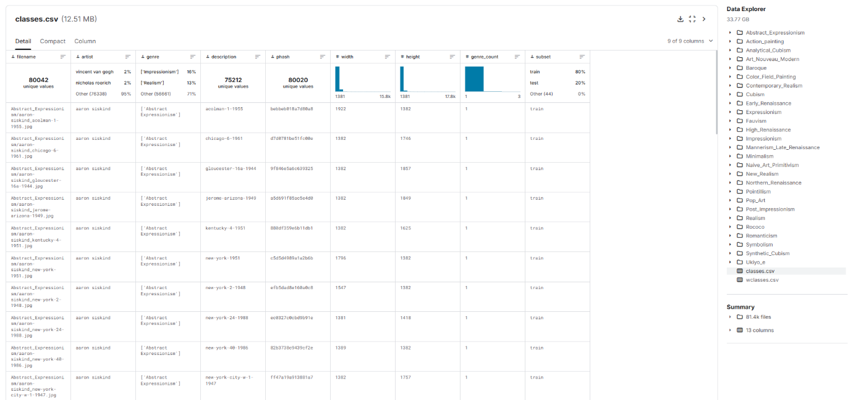

Figure 8 – WikiArt metadata.csv table on Kaggle

The selection of the WikiArt dataset as a source is substantiated by considering the user experience of a real situation in conditions of limited accessibility of information about art collections in museums. Although there exist free APIs in today’s museums, their usage involves large financial investments for data collection, cleaning, and integration. In relation to the research topic and thesis work in general, WikiArt is used as an approximation to the museum collection, making it possible to test recommendation systems. However, it is important to note that, within the system architecture, there exists an opportunity for integrating real museum datasets in the future.

Data preparation and processing
Following selection of the dataset, data pre-processing took place to form a balanced and analyzable sample of data. The WikiArt base sample includes many pictures classified according to various styles, however, they are unbalanced, Figure 9. It is obvious from the figure that certain styles include much more objects than others. Consequently, their inclusion in the recommendation system will skew its results toward popular styles.

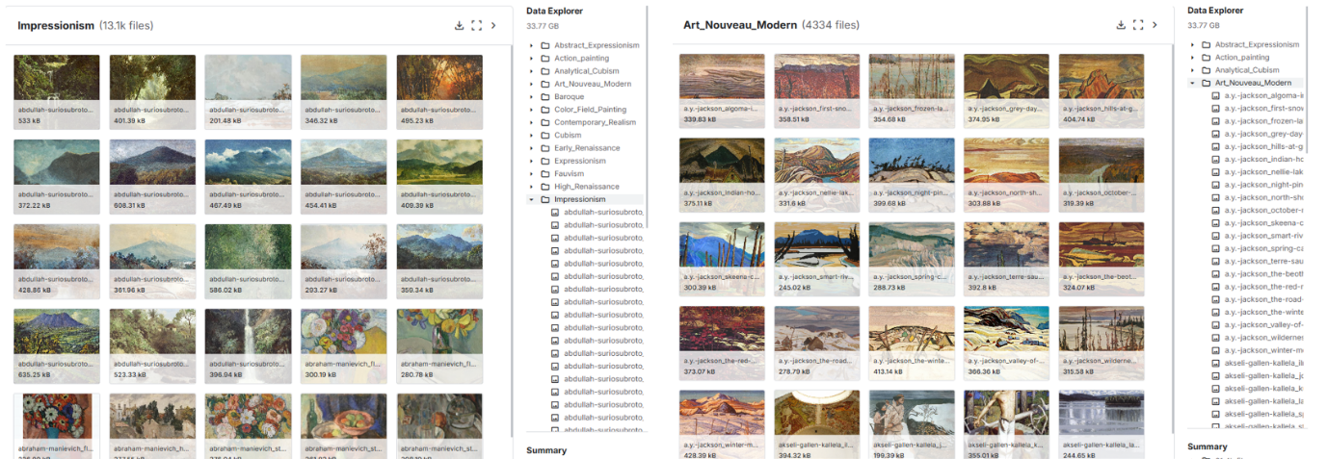

Figure 9 – Comparison of Impressionism and Art_Nouveau_Modern

To counterbalance this phenomenon, a data balancing strategy was applied. In the process, a specific amount of images was taken into account for each chosen art style, and the total amount of images considered was two thousand in this research (sample_per_style=2000). Thus, we managed to generate an image set in which all the categories had equal representation, which led to a better performance of the recommendation algorithms.
Balancing was performed using a script called build_balanced_dataset.py, developed as part of the project, Figure 10. This script filtered images based on a list of preset styles and randomly selected a certain number of objects for each style. To ensure reproducibility of the results, a fixed random_seed parameter was used during the sampling process, which guarantees repeatability of sampling over multiple runs.

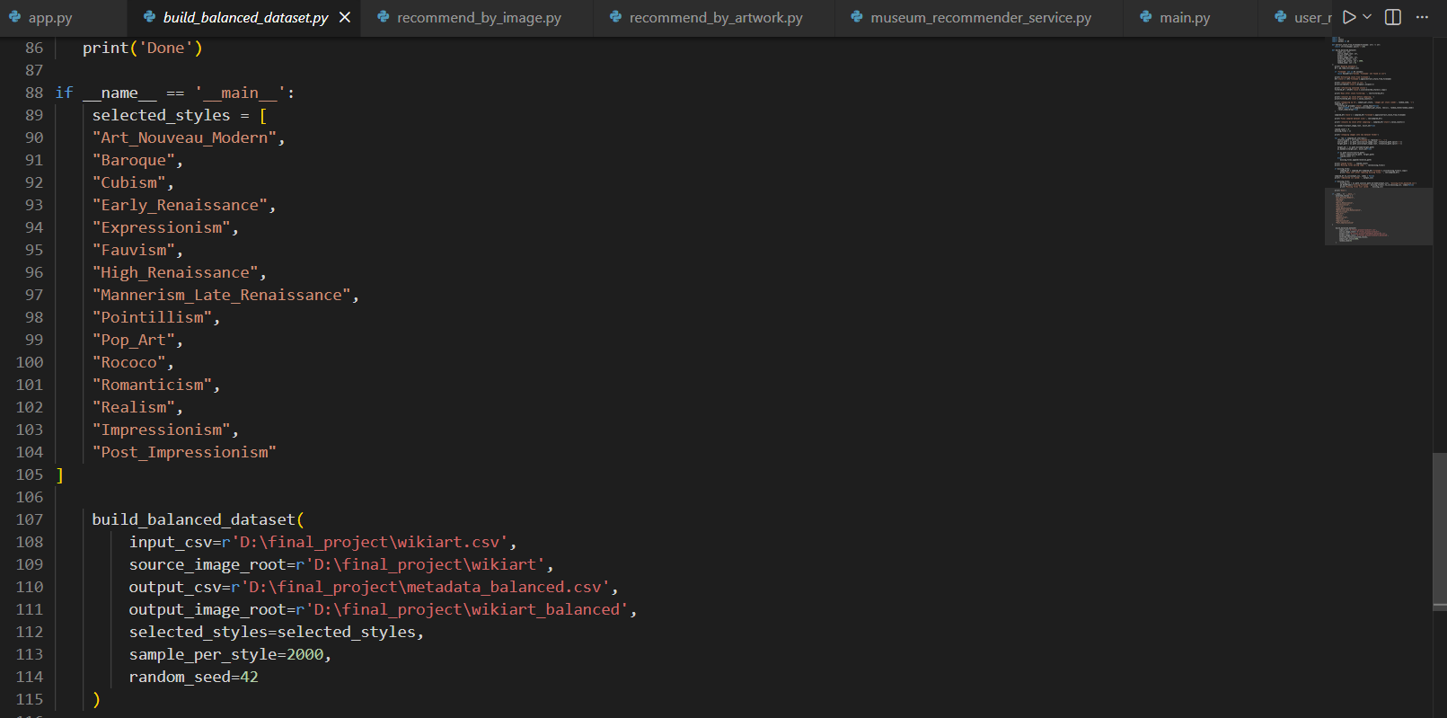

Figure 10 – build_balanced_dataset.py

The output of the script comes out in the form of metadata, which consists of the following information about each picture: name, author, genre, style, and file location in the filesystem. Also, there is a list of missing/corrupted files called missing_files_balanced.csv. This way we have created a monitoring mechanism of dataset consistency.
Initially, the file called metadata_balanced.csv consisted of 24774 lines and 10 columns, Figure 11. While working with the data during analysis and data cleanup, all redundant and non-functional attributes that did not influence the work of the recommendation system were deleted. In the end, we reduced the number of columns up to 5 while keeping the quantity of records unchanged. Thus, the cleaned and balanced data set has been saved into the file called metadata_final.csv and used in subsequent steps of the system building process, i.e., embedding and recommendation.

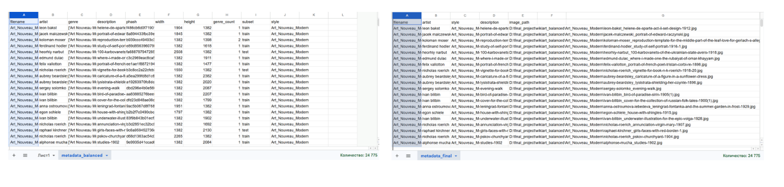

Figure 11 – Comparison of metadata_balanced.csv and metadata_final.csv

The resulting balanced dataset will be used to create embeddings and make recommendations. The process of converting the initial data into a structured and balanced format is an important phase in the implementation of the system to ensure its stability and reliability. The performed data preparation process allows for reducing the discrepancy in classes and improving the quality of recommendations.

Image embedding and image similarity assessment methods
One of the main stages of creating the recommendation system is the transition from images of artistic works to the numerical data necessary for further analysis. In order to solve this task, embeddings are used – vectors that represent the images and their features visually and semantically, Figure 12. They are numeric vectors of a certain size and include information about the images that are fed into the system. When training the model, vectors are created such that the similarity of images to each other corresponds to their proximity to each other in space [8].
With the employment of embeddings, we are able to think about the image not only as pixels but also as numeric vectors with valuable information stored inside. The ability to compare, search, and cluster objects comes due to the fact that computations are done not with images themselves but their numeric representation, especially when determining similarity between two images using distance metrics such as cosine similarity [24].

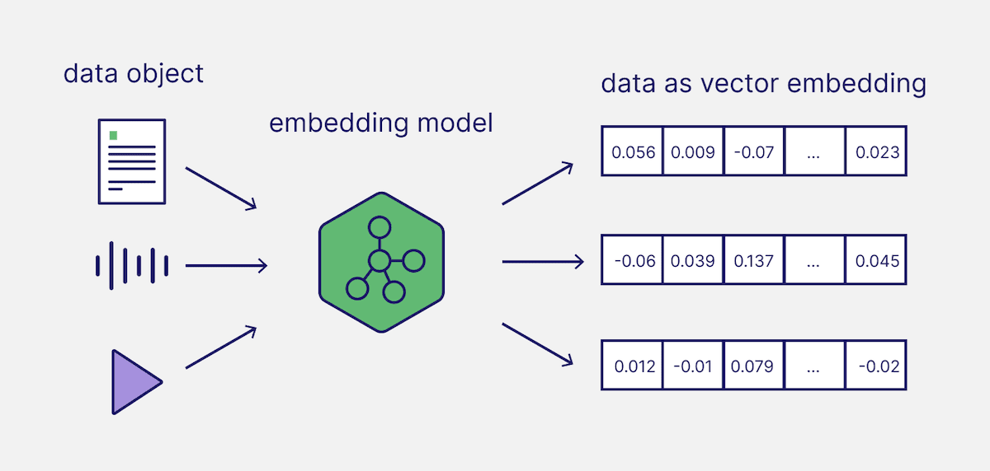

Figure 12 – Illustration of how embedding model works

When working on completing the thesis, the CLIP model proposed by OpenAI has been used to create embeddings, allowing for comparison of images and their textual annotations within one vector space [20]. This model is a multimodal neural network model that is trained on a massive data set including image-text pairs [23]. It allows you to link the information contained in both elements.
Considering architecture, CLIP includes two separate encoders – one is dedicated to visual information, and another focuses on textual data. Specifically, visual information can be processed using Vision Transformers or convolutions, and then represented as a vector, whereas text will undergo the same transformation procedure. Learning objectives include making sure that vectors representing images and texts correspond to each other, but vectors not associated with each other should have a substantial difference. This is achieved via contrastive learning, where the model learns to identify true pairs from false ones [20].
Among the main strengths of CLIP is its capacity for generalization, which makes it possible to perform zero-shot learning tasks, Figure 13. This means that the network can operate efficiently on classes of data unseen in the training process. This characteristic is especially valuable in the application of museum management systems due to the large variety and uncertain categorization of works of art.

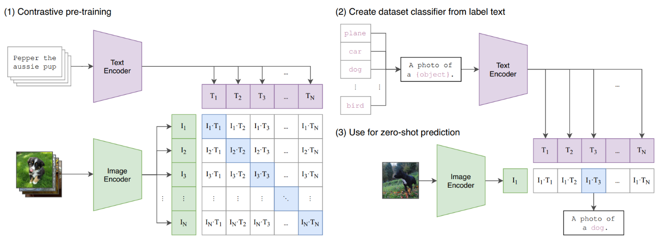

Figure 13 – Detailed illustration of CLIP model from GitHub

Another approach would be to employ CNNs like ResNet (ResNet50, for instance). These models are extensively utilized in extracting features from images. The problem is that CNNs, like most other neural networks, are trained for classification tasks and emphasize learning low- and mid-level visual attributes like texture, shape, or object identity. As a result, there are certain restrictions on how well the neural network can factor in the semantic closeness of artworks. In other words, recommendations based on these embeddings would not be quite meaningful for the end-user.

Table 2 – Comparison of ResNet50 and CLIP models

Criterion | CLIP | ResNet (ResNet50)
Model Type | Multimodal (image + text) | Convolutional Neural Network (CNN)
Primary Task | Image–text matching | Image classification
Training Type | Trained on image – text pairs | Trained on labeled images
Context Understanding | Yes (captures meaning and style) | Limited
Feature Level | High-level (semantic) | Low- and mid-level (shapes, textures)
Use in Recommendations | Suitable for similarity-based recommendations | Limited suitability
Data Requirements | High (zero-shot capability) | Limited
Similarity Quality | High | Lower

Embedding is carried out in several consecutive steps. Initially, the pictures of the input dataset are fed into the system and converted into a suitable format for the subsequent processing of the model. After that, each picture is fed into a neural network, yielding a vector of fixed dimensionality, in our case, the size of the vector equals 512. In addition, it is required to normalize the vector in order to make sure that the computation of similarity is performed correctly.
Normalization is performed using the following expression:

$\hat{A}=\frac{A}{\left\|A\right\|}$ (1)

where A is the original embedding vector, $\hat{A}$ is the normalized vector and $\left\|A\right\|$ is the Euclidean norm of the vector defined as follows:

$\left\|A\right\|= \sqrt{\sum_{i=1}^{n}{A_{i}^{2}}}$ (2)

Because of the normalization process, the magnitude of every vector is transformed into one (the norm of the vector equals one). Consequently, the position of all vectors on the surface of the hypersphere in multidimensional space will be defined.
This step is extremely important in embedding processing because it gives the opportunity to ignore the impact of the scale of the vectors and pay attention only to their direction. It is particularly critical when measuring the distance by cosine similarity, where the angles between vectors are calculated instead of lengths [24]. Without normalization, vectors having greater norms may appear as more important ones; thus, the outcome will become distorted, for example, in recommendation systems.
The embeddings are stored in a different file using the NumPy array format (embeddings_balanced.npy). This ensures that the embeddings do not need to be computed every time a user requests the program to process an image, thus making the program faster. This becomes particularly relevant when dealing with large numbers of images, often in the thousands or tens of thousands [21].
For assessing the extent to which different versions of artworks are similar to each other, there is a method called cosine similarity, which calculates vector proximity [22]. This is one of the techniques employed in information retrieval and recommendation systems, as this technique considers the direction of the vectors, but not their magnitude. That is, this becomes important particularly in the case of normalized embeddings, as it concentrates on object similarity.
In an intuitive manner, it is clear that the measure of cosine similarity reflects the angle formed by two vectors in n-dimensional space; the smaller the angle, the higher the similarity between objects is said to be, Figure 14. It should therefore be more convenient to calculate the scalar product for normalized vectors because the angle is then calculated between these vectors through a simplified form of the formula in question, which extracts the content of the reduction [20][25].

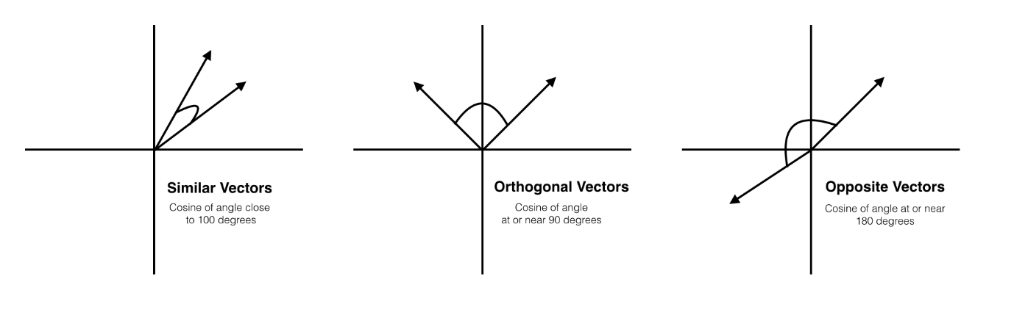

Figure 14 – Illustrate of how cosine similarity work

This technique is popularly utilized in the current era of information systems. For instance, the use of cosine similarity in the searching for services and in recommendation systems is applied to platforms such as Netflix and Spotify, in trying to find similarities of items as per the user's preference. Additionally, the cosine similarity is heavily utilized in search engines for images and texts, as well as in natural language processing.
In other words, it means that embeddings can be utilized not only for comparing two images but also for their numerical comparison and constructing the recommendation system on their basis. The use of CLIP will be more prospective here due to the better "comprehension" of the visual and semantic part of paintings by the neural network, as opposed to classical neural network architecture like ResNet50, respectively, recommendation accuracy can be higher.

Recommendation Generation Algorithm
The recommendation algorithm is one of the most important components of the developed software, since it defines what artistic works are going to be recommended to the user. The recommendation software employs the content-based methodology, which relies on visual aspects of images as well as user preferences. Content-based recommendation systems are one of the types of recommendation techniques, where recommendations depend not only on the attributes of objects but also user preference information. While collaborative recommendation methodologies imply the analysis of preferences of other users, content-based methodologies study the attributes of objects and select those that match the preferences of the user [10][11].
The essence of this approach consists of presenting to the user objects having properties similar to those he gave high ratings. In the research, these objects are image embeddings possessing both visual and semantic properties [8]. This means that recommendations are made on the basis of the personal profile of the user, not on the popularity or preference of other users for some objects [9].
There are certain strengths in this methodology as well. For starters, it does not rely on any user base and details on interaction between them and thus, this strategy will work perfectly from the early stages of the system. Moreover, this method will allow creating personalized recommendations based on a limited dataset regarding the behavior of users. What is more, this method will be much easier to understand, as there is a possibility to explain recommendations based on the similarities between properties of objects. At the same time, there are also some weaknesses in this method [14] [15]. For instance, content-based recommendation strategies can produce what is known as the "recommendation bubble" where a person will only receive offers of similar objects that have been chosen previously.
The recommendation generation algorithm is based on embeddings of images obtained using the CLIP model. Each work of art is represented as a vector of a fixed dimension, which makes it possible to compare objects in a multidimensional space [20]. To assess the similarity between images, a cosine measure is used to determine the degree of their visual and semantic proximity [22].
The recommendation generation algorithm supports a variety of scenarios corresponding to different stages of user interaction with the service.
The first scenario for generating recommendations utilizes the idea of finding similar objects. In this scenario, the selected by the user piece of art is treated as a query, from which its vector is extracted and compared to the vector of all other images included in the dataset [24]. The cosine similarity between the vector of the query and other vectorized works of art is calculated [25].
The first scenario in recommendation generation utilizes the idea of finding similar objects. As a query, the user-chosen artwork will be utilized, and its vector will be used to compare the query image with all other images included in the dataset. This comparison is carried out using the cosine similarity measure.
Values of similarity are numeric estimations of closeness of objects within multidimensional feature space. When calculating cosine similarity, the closer it is, the more similar the pictures will be to each other. Next, results are sorted in decreasing order, and the user receives the list of closest companies (Top-N recommendations). If you want to make your recommendation more relevant, it is possible to skip a new picture among the result, as well as those users with whom he has already communicated. In this way, repetition will be avoided and recommendations will become more relevant.
This approach can be called searching classical neighbors on the embedding plane. The benefits of this method include fast computing and the opportunity to find not only visual but also semantically similar objects at the same time without an additional model training. Thus, due to this method, it will be possible for the user to discover art according to the similarity of objects, Figure 15.

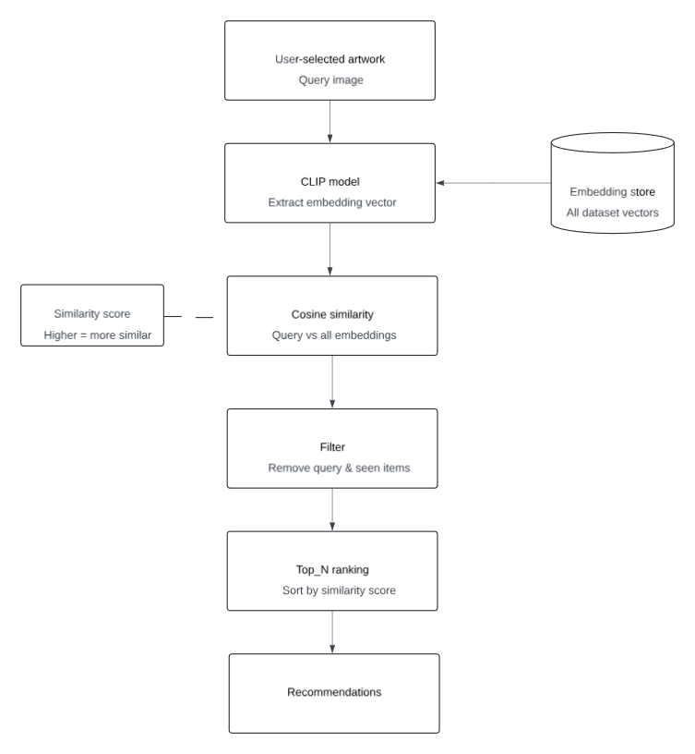

Figure 15 – Scheme of first scenario of recommendation system

The second scenario relates to building personal recommendations. For that, data on user behavior is collected, that is, those objects for which the user would put a «like». Based on embeddings of images that have been of interest to the user, a preference vector is constructed for the user. It is the average value of all image embeddings that the user likes.

$u=\frac{1}{N}\sum_{i=1}^{N}{A_{i}}$ (3)

Where $A_{i}$ the embeddings correspond to the images liked by the user, and $N$ denotes their number.
The summary vector is a generalization of the numerical model of the user’s preference for the visual content. This approach enables you not to analyze the objects individually, but the features aggregated within each of them, whether that is a certain artistic style, composition, or semantics.
After that, the user vector is used as the query for recommendation. This is done using the calculation of cosine similarity measure between the preference vector of the user and image vectors. In particular, cosine similarity is one of the classical measures for vector comparison and has wide use in current embedding-based systems, such as recommendation or search engines [24].
The list of images based on the level of their similarity value will be generated. This means that the top N images having the highest similarity value will be provided to the user according to his preferences.
In order to enhance the quality of suggestions, the images which the user has already interacted with should not feature in the final list. Diversity of certain elements may also be considered, which will prevent an excess homogeneity among the suggestions. The idea behind this is to limit the “information bubble” effect of the content-based recommender system [11] [14].
This algorithm is a system for personalized recommendation and relies on a vector presentation of users’ preferences. Due to using embeddings and cosine similarity metrics, it becomes possible to efficiently recognize semantically similar items and provide recommendations based on users’ personal visual preferences, Figure 16.

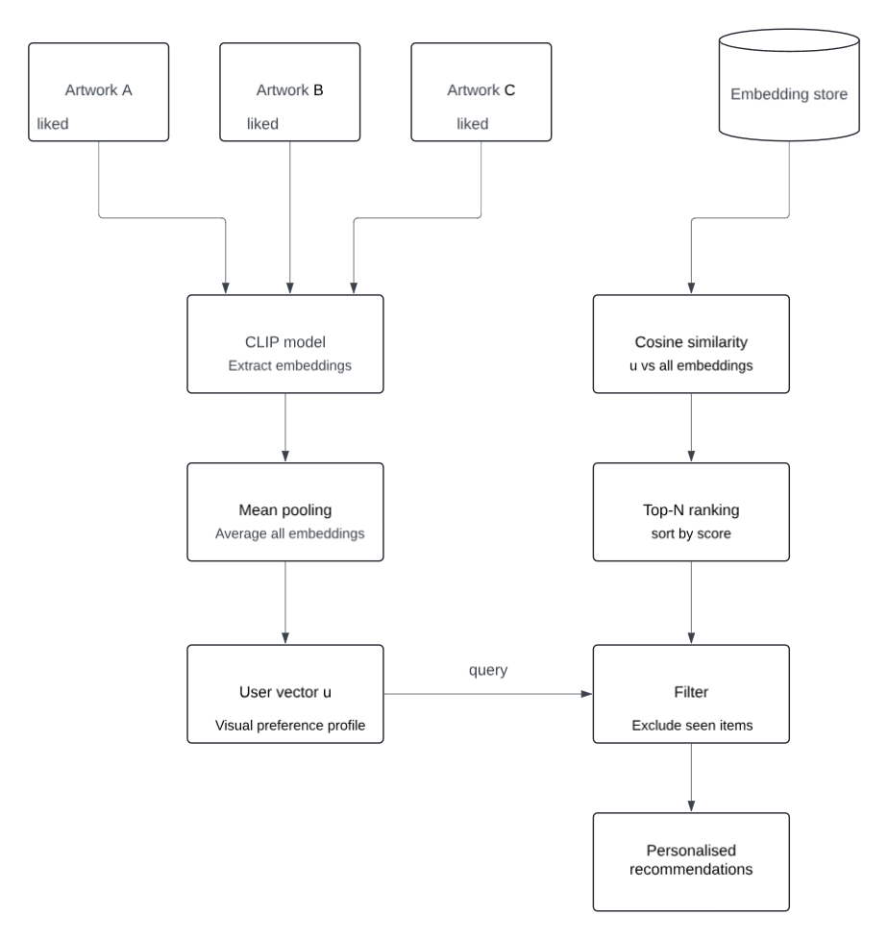

Figure 16 – Schema of second scenario of recommendation algorithm

This system also focuses on issues such as the cold-start problem or insufficient knowledge of the user. The cold-start problem is one of the most important ones in recommendation systems. It consists in the inability to provide personalized recommendations in the beginning phase of the interaction process [16].
In order to cope with this issue, the system suggests an opportunity for initial preference detection (onboarding). In the process, the system offers the user a limited collection of artworks that was chosen with the goal of being representative in terms of various artistic styles. This strategy allows detecting the preferences of the users visually, irrespective of any interactional history with them.
The preference profile of the user will be created based on their choice made during the onboarding stage. Consequently, recommendations can be generated. It is thus possible to ensure high-quality recommendations within the first few days of usage, which partially solves the cold start problem.
The algorithm will also consider the parameter of the style of artworks. For example, for items belonging to the same style as the tastes of the user, a special coefficient will be taken into account, which we will call a style bonus. It will positively affect the result of the object's assessment. In other words, besides calculating the numerical correspondence between embeddings, we will take into account the interpretation of their features.
The implementation of style bonus can be seen as another way of ranking that amplifies the weight of the most important features from the point of view of the user. This approach is quite popular in recommendations because of its positive effect on the outcome of the process [10] [11].
To make sure that there is diversity in the recommendation list, artworks which have already been engaged by the user are filtered out from the list. This ensures that the same artwork will not be recommended again, Figure 17.
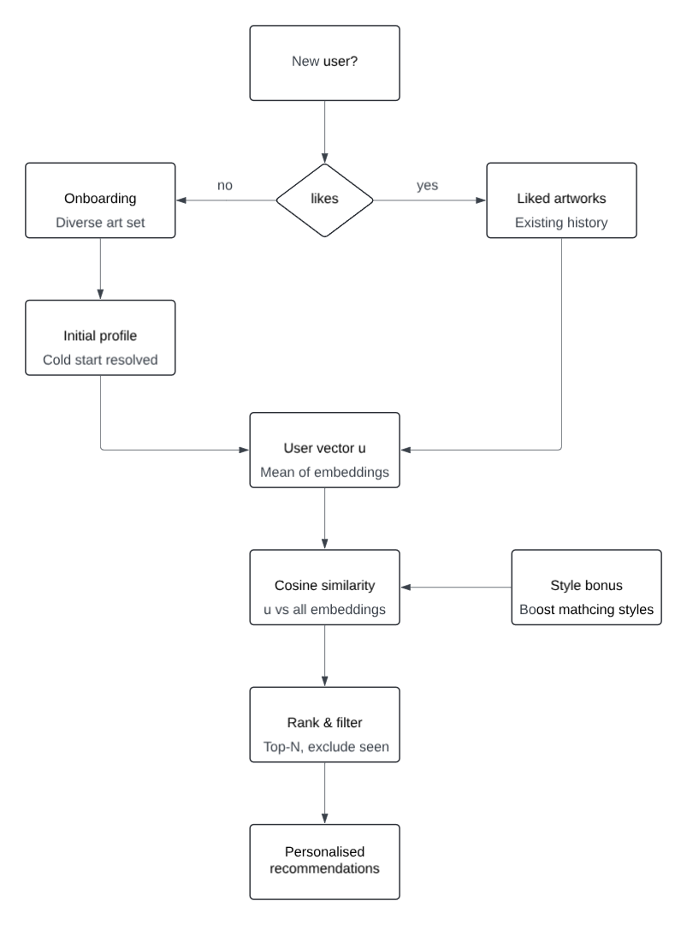

Figure 17 – Schema of Onboarding

The content-oriented methodology used in this thesis allows one to consider the visual features of artworks by relying only on the preferences and tastes of the user.

Database structure
As a relational database management system, the relational database PostgreSQL was selected. The choice of this particular database is explained by the high performance, reliability, and possibility of conducting complex queries, which are needed when recommendation systems work with correlated data. While developing the database, the requirement to have information regarding users, artwork, as well as the interaction of users and artwork with the system was taken into consideration. The database itself includes several main objects, which are presented in tables.
It is the table where we will save data regarding the system’s users. This data includes such attributes as a user id, login, password in hash format, plus other parameters that would be required for proper operation of the system. The users table is a main database table, from which you can find data on any entity.
The artworks table holds details about the paintings included in the application system. Details held include the image details, such as the filename, artist, genre, art style, and the location of the image file. This data is used for recommending objects within the interface [10] [11].
The interactions table is used for recording any kind of interaction between the user and the system. This includes any actions done by the user, including looking, liking, or ignoring something. The interaction table has links both to the user and to the particular artwork, and therefore allows analyzing the user's behavior and using the results to create recommendations, Figure 18.

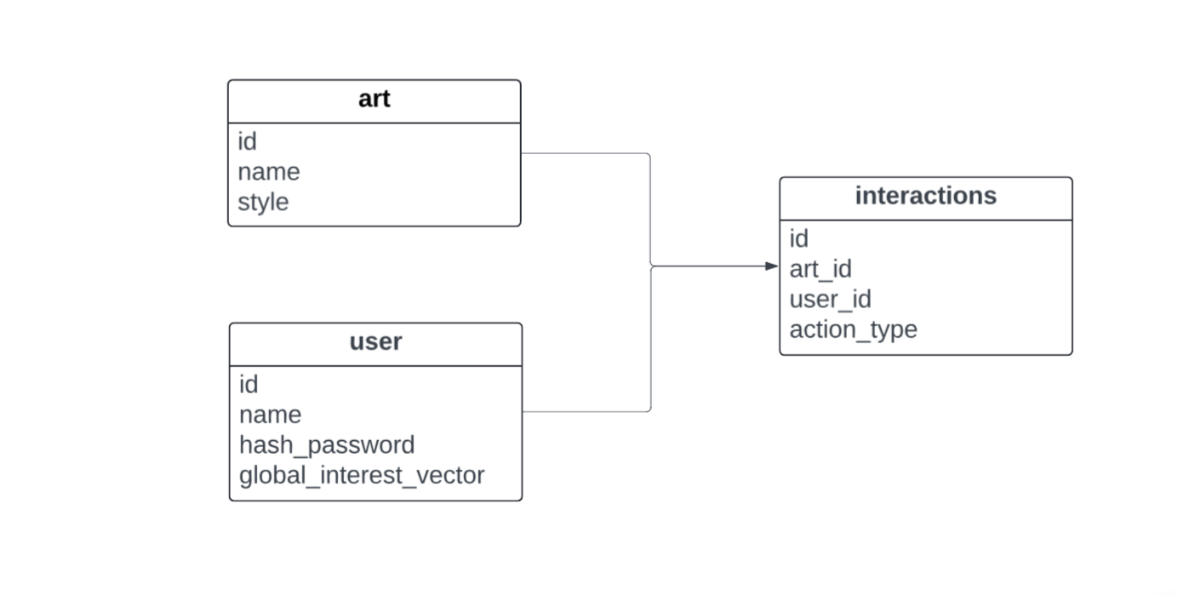

Figure 18 – DB schema

Furthermore, the favorites database is introduced into the system, which is supposed to save the chosen artwork pieces. Thus, the user will be able to keep track of objects of interest and review them later on. The mentioned database can serve as one more information source for users’ preferences analysis.
In order to increase the scope, there is also a table called user_preferred_styles which contains the preferred styles of the user. This table may contain information about the styles and the importance attached to those styles by the users. In other words, it contains the preference level of a particular style by the user.
The dependencies among the tables are established through the use of foreign keys. In other words, the interactions table is related to the users and the artworks table, allowing you to ensure the integrity of your data and know the actions undertaken by your users [16].
When developing the system, a universal application, known as DBeaver, which allows interacting with the database and administrating it was utilized. DBeaver is designed to work with different databases including PostgreSQL and offers the possibility to work with data through the convenient GUI.
The employment of the tool has allowed considerably simplifying the process of creating and modifying the database as well as its debugging. It has helped to create tables, write SQL commands and verify the correctness of the database structure, as the program allows displaying database schemas which are helpful while designing and understanding the relationships between the tables.
In conclusion, due to using DBeaver for developing and debugging the database, an efficient database schema was created that is helpful in storing and processing the necessary information required for running the system. The usage of relational database schema guarantees the high level of data security and integrity and gives considerable opportunities for further development.

Web Application Architecture
The proposed recommendation system is realized as a web application, which is developed based on multi-tier client-server architecture. It is the particular architecture for the web application, which allows dividing user interface, server logic, and database layer from each other. In this way, we can ensure convenient and flexible maintenance of the system, Figure 19.
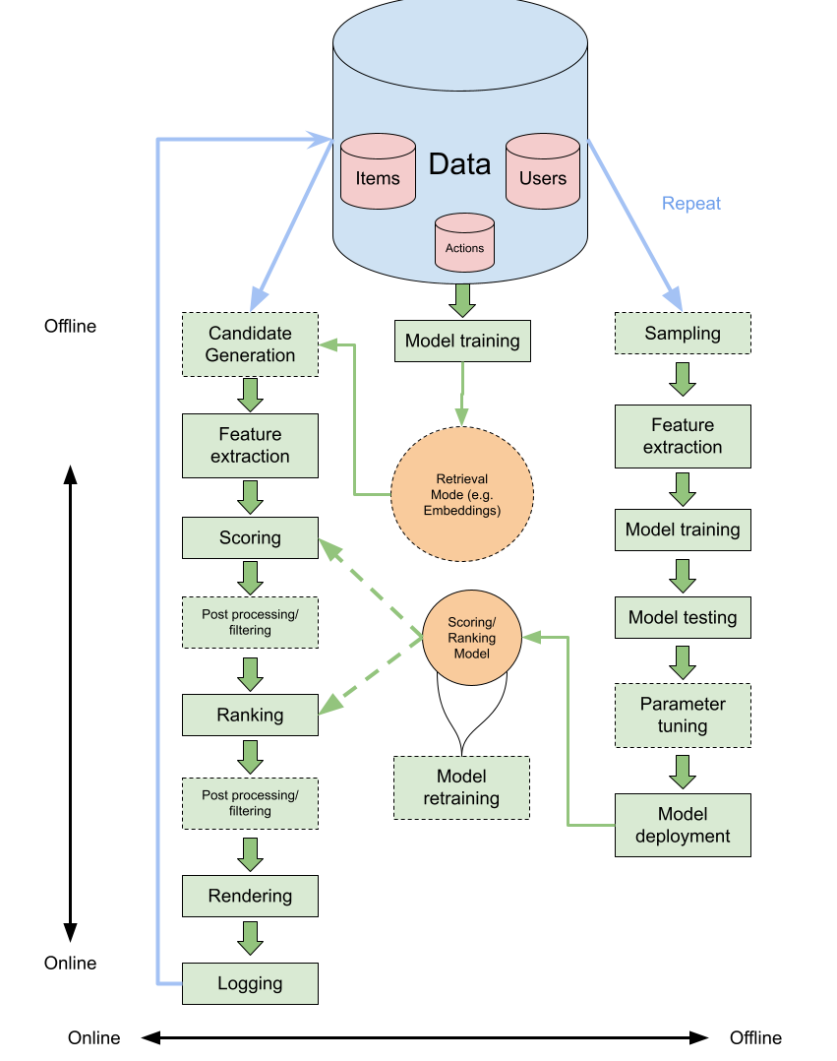

Figure 19 – Example of multi-tier client-server architecture

Client-server, information system architecture, when the client side (user interface) is isolated from the server side (business logic and data processing). The client's task is to interact with the user, send requests, and the server receives requests, processes, does the calculations, and gives results.
Modern information systems have a client-side implemented as a web interface operating in a browser, while the server-side uses an application programming interface (API) that can access data and functionality of the system. This model is commonly applied in distributed systems and web-based software products because you are able to implement each component of your information system independently. I chose FastAPI as the server part for my software project. FastAPI is an innovative and lightweight framework for developing fast and efficient applications and REST APIs written in Python. This framework uses an asynchronous execution model, that is, ASGI, enabling you to handle many concurrent requests quickly. One of the key features of this framework is the use of Python type hints, which guarantees input validation and automatically generates interactive Swagger documentation without additional effort.
The choice of the framework depends on the requirements related to the speed of operation and simplicity of development. The difference between Flask and FastAPI is that the former is a minimalistic framework and requires additional programming for such features as data validation, data serialization, and documentation generation. It decreases the amount of code needed to be written and the number of mistakes that may occur during request handling.
Unlike Django, the usage of FastAPI will be simpler in this case. Django was made for building whole websites with ORM, templating engines, and the built-in administrative panel. That is why, for implementing the task of creating the API and working with queries, Django is excessive. Moreover, the main aim of the backend part of the project is just to create an API that is going to use the recommendation algorithm.
Justification of the server framework choice is made in the form of comparison of some common frameworks (Table 3).

Table 3 – Comparison of FastAPI, Django, Flask frameworks

Criterion | FastAPI | Flask | Django
Type | Asynchronous API framework | Minimalistic framework | Full-featured MVC framework
Performance | High (ASGI) | Medium | Lower (due to full-stack architecture)
Data Validation | Built-in (Pydantic) | Requires manual implementation | Partially built-in
API Documentation | Automatic (Swagger) | Not available by default (requires integration) | Not available by default (requires DRF)
Ease of API Development | High | Medium | Lower (due to complexity/overhead)
Flexibility | High | Very high | Limited by framework structure
Suitability for ML/API | Yes | Partial | Overkill

The user interface (UI) is implemented using the Streamlit library, which is an efficient solution for building interactive apps written in Python. The idea of Streamlit is that by writing a simple Python script, you can get a fully functional web app without developing any additional frontend (HTML/CSS/JavaScript). Such an approach may be particularly helpful in developing applications for Data Science and ML.
Compared to the traditional approach with HTML/CSS, where the user interface is created independently and linked with the backend using specific methods, the use of Streamlit means implementing the user interface declaratively by means of Python scripts. While compared to other popular frontend libraries, such as React, it allows avoiding implementation of a dedicated client application and interaction with the backend through JavaScript. In contrast to React-based approaches, it is necessary to implement additional functionality associated with data exchange with the server and management of its state and interface.
To justify the choice of the user interface, a comparative description of the technologies used is provided (Table 4).

Table 4 – Comparison of Streamlit, HTML/CSS/JS, and React

Criterion | Streamlit | HTML/CSS/JS | React
Development Type | Python-only | Separate frontend | Separate frontend
Required Technologies | Python | HTML + CSS + JavaScript | JavaScript + React + API
Development Speed | High | Medium | Lower
Integration with ML | Direct | Via backend | Via API
Interactivity | Built-in | Requires JavaScript | High
Complexity | Low | Medium | High
Suitability for Prototyping | Yes | Partial | Challenging
Suitability for Production UI | Limited | Yes | Yes

The key characteristic of the Streamlit framework is that it employs a declarative approach: interface components such as buttons, images, and forms are defined in Python code here, and all modifications are automatically applied to the browser immediately. This ensures convenient and rapid development, while implementing all types of analytical algorithms and machine learning models is easy.
Streamlit provides useful capabilities for obtaining user input and updating the interface dynamically, which enables the recommender system to become interactive. For instance, Streamlit supports all features of our recommender system: registration, authentication, browsing paintings, working with recommendations, and managing favorites. Users may choose the artworks that they find appealing, get instant recommendations, and save their favorite choices.
The connection between the client and the server side of the app is provided via HTTP requests. If a user executes some command (for instance, asking for recommendations or putting an object in favorites), then the interface sends this request to the FastAPI server that processes it and gains access to the database or recommendation system if needed, after which a response is formed and returned to the client.
This transfer is done via the REST API protocol and ensures the separation between the server and client code. Therefore, it becomes possible to develop, modify, test, and scale separate modules of the app separately from each other.
Basic computations, like finding cosine similarity and computing the preference vector of a user, can be done at the server level. The reason why this is beneficial is that it helps concentrate the business logic in a single place and make the system more secure, as well as improve its performance by keeping the client-side load light.

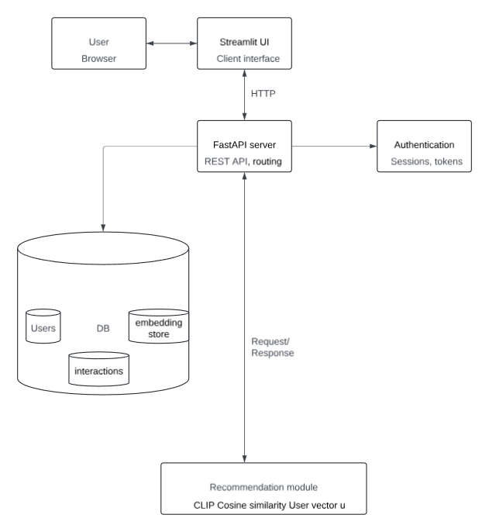

Figure 20 – Schema of Web Application Architecture

From an architectural standpoint, a web application can be perceived as a set of various layers. The first one is called the presentation layer, and it is realized using Streamlit as the tool and focuses on the interface part. The second one is called the business logic layer and focuses on processing queries, managing data, and implementing recommendation algorithms using FastAPI as the platform. Next comes the data layer, consisting of PostgreSQL and the embedding repository, storing data and providing it.

Recommendation system design and implementation

Physical modeling of a database for storing museum information
Physical database modeling represents a stage at which the logical data model gets implemented within the database management system chosen by the developer. On this stage, it is required to specify tables and attributes, including fields, data types, keys, and constraints, in order to assure the data correctness.
Within the work done within the context of the thesis, a database was implemented using the PostgreSQL DBMS. This choice is justified by the stability and high quality of the product that supports the relational model of data and allows processing relations between pieces of information efficiently, which is extremely necessary when creating a recommendation system. DBeaver was used to work with the database and check SQL queries executed against it. This software solution is a powerful and convenient tool for working with different databases and provides an opportunity to perform operations on the data.
In the process of database design, the rules of data normalization were used, which were intended to remove redundant data and avoid inconsistencies while adding, changing, and deleting data. Separation of data into different tables (users, works, interactions) made it possible for us to ensure consistency in data and facilitate data processing.
The database was implemented through SQL queries, which included the creation of tables, specification of primary and foreign keys, and setting up integrity constraints. Creation of user tables can be illustrated by the following example in the Figure 21:

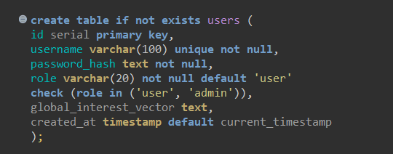

Figure 21 – Example of SQL query

The connection to the database was carried out using the psycopg2 library in the Python environment to integrate with the server side of the application and perform data reading and writing operations in the Figure 22:

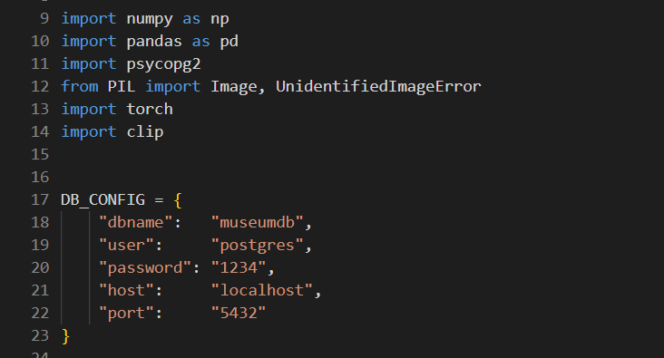

Figure 22 – Connection with DataBase.

The application's database is designed to store information about users, works of art, interactions, onboarding answers, favorites, and user preferences. The main tables include User, Artworks, Interactions, Onboarding Answers, Favorite, and User Preferred Styles. Each table has well-defined fields, data types, and constraints to ensure data integrity and consistency. Below are descriptions of the key tables with their structure.
The artworks table is designed to store information about works of art. It contains basic metadata such as the file name, artist, description, style, and path to the image. This table is used as the main database of objects for making recommendations, Table 5.

Table 5 – Table artworks

Field Name | Data Type | constraints
artist | text
created_at | timestamp | default current_timestamp
description | text
filename | text | not null
id | serial | primary key
image_path | text
style | text

The users table stores information about system users, including the username, password hash, and role. It also provides a field for storing an aggregated vector of user interests. This data is used to personalize recommendations, Table 6.

Table 6 – Table users

Field Name | Data Type | constraints
id | serial | primary_key
username | varchar(100) | unique not null
password_hash | text | not null
role | varchar(20) | not null default 'user'
global_interest_vector | text
created_at | timestamp | default current_timestamp

The interactions table records user actions with works of art, such as viewing, liking, or skipping. It connects users and objects via foreign keys. This data is the basis for analyzing user preferences and making recommendations, Table 7.

Table 7 – Table interactions

Field Name | Data Type | constraints
id | serial | primary key
user_id | int4 | foreign key(users.id)
artwork_id | int4 | foreign key(artworks.id)
action_type | varchar(20) | not null
created_at | timestamp | default current_timestamp

The onboarding_answers table is designed to store the user's answers to questions during the initial onboarding. It allows you to collect initial information about the user's preferences. This data can be used to solve the cold start problem, Table 8.

Table 8 – Table onboarding_answers

Field Name | Data Type | constraints
id | serial | primary_key
user_id | int4 | foreign key(users.id)
question_key | varchar(100) | not null
answer_value | text | not null
created_at | timestamp | default current_timestamp

The favorites table contains a list of the user's favorites. It provides quick access to saved objects and prevents duplicate entries due to a unique constraint. The data is used to generate personalized recommendations, Table 9.

Table 9 – Table favorites

Field Name | Data Type | constraints
id | serial | primary key
user_id | int4 | foreign key(users.id)
artwork_id | int4 | foreign key(artworks.id)
created_at | timestamp | default current_timestamp

The user_preferred_styles table stores the user's preferences for art styles, indicating the weight of each style. This allows you to take into account the interests of the user at a higher level of abstraction. The table is used to improve the accuracy of recommendations and their diversity, Table 10.

Table 10 – Table user_preferred_styles

Field Name | Data Type | constraints
id | serial | primary key
user_id | int4 | foreign key(users.id)
style | text | not null
weight | float8 | default 1.0

It should be mentioned that the data structure represents the fundamental types of relationships typical for relational databases. Thus, there are one-to-many relationships between users and interactions, as well as between artworks and interactions since one user may have performed different actions (such as viewing, liking, or skipping a work of art), and one work of art may relate to actions taken by various users. The possibility of storing a history of actions performed and analyzing the user's behavior is ensured precisely because of such relationships.
A many-to-many relationship between users and artworks is implemented with the help of intermediary tables such as interactions and favorites. These tables can be defined as associative entities used to combine users and objects and provide information about the nature of their interaction. Thus, the information about actions performed by users is kept in the interactions table, while selected works of art are stored in the favorites table.
Such approach to creating relations makes it possible to maximize data modeling flexibility and efficient management of information related to users' interactions and, more importantly, corresponds to the logic of the recommendation engine operation.
In order to demonstrate the organization of the database, it is suggested to use the ER diagram that depicts the tables and their connections. Figure 23 depicts the following entities: User, Artworks, Interactions, Onboarding Answers, Favorite, and User Preferred Styles. It is necessary to specify the primary and foreign keys for these entities.

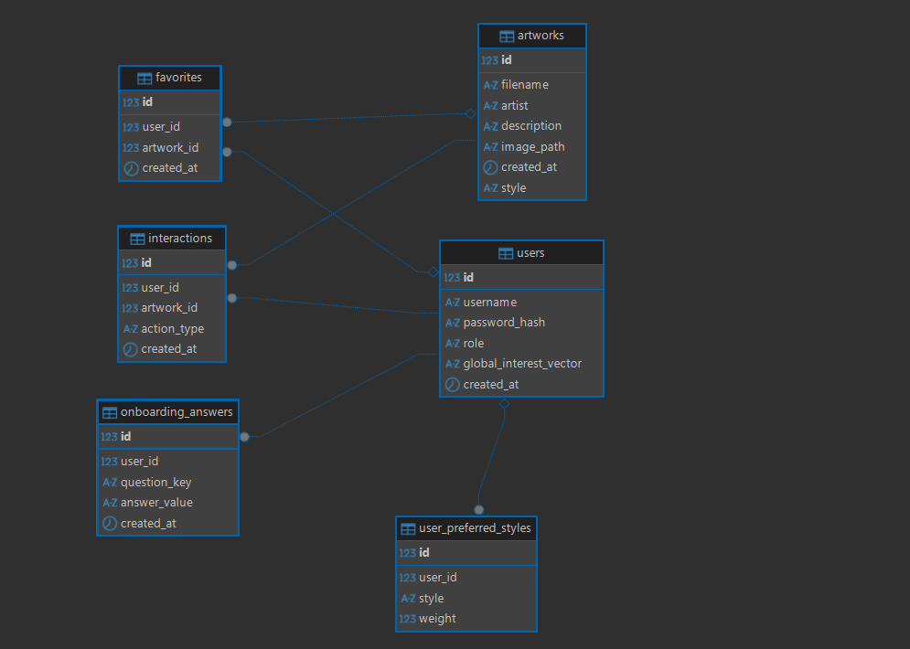

Figure 23 – ER diagram

In other words, the database design took into account the use of normalization of relations, the creation of relationships between tables, the interaction with the server side of the application, and proper functioning of CRUD operations. The designed data structure provides for the integrity and scalability of the processed data in the recommendation system.

Implementation of the recommendation algorithm
The algorithm described in this article is implemented in Python and used as a part of the application's backend. The majority of logic is stored separately in the form of the MuseumRecommendationService class and is related to uploading data, working with embeddings, constructing user profile, and generating recommendations. Such organization of code is efficient because it is convenient in terms of centralized business logic implementation.
Once the initialization stage of the server side of the system is carried out, the necessary information will be loaded to RAM. More specifically, image embeddings, which have been pre-calculated before, will be read from an .npy file, while metadata of artworks will be taken from a .csv file (self.embeddings and self.metadata, respectively). By doing so, unnecessary recalculations will be avoided, and the speed of queries will be accelerated significantly.
In order to speed up calculations, normalization of embeddings will be done. That is, all embeddings will be brought to the same size. It will make it possible to use the dot product operation of vectors as a metric for cosine similarity, rather than computing the formula of the cosine measure. Thus, requests will be processed much faster and more efficiently.
At the initialization stage, a correspondence cache will be created. The purpose of this cache is to link image filenames to their unique identifier in the database. This way, unnecessary database lookups will be avoided when doing search and recommendation operations.

class MuseumRecommenderService:
def __init__(self, embeddings_path: str, metadata_path: str, model_name: str = "ViT-B/32"):
print("Loading data...")

self.embeddings = np.load(embeddings_path).astype(np.float32)
self.metadata = pd.read_csv(metadata_path)

norms = np.linalg.norm(self.embeddings, axis=1, keepdims=True)
norms = np.where(norms == 0, 1.0, norms)
self.embeddings = self.embeddings / norms

self.filename_to_index: Dict[str, int] = {
row["filename"]: idx
for idx, row in self.metadata.iterrows()
if row["filename"].strip()
}

Listing 1 – Loading and Normalizing Image Embeddings. Indexing works of art by file name

The algorithm involves calculating the similarity of vectors using cosine similarity. As soon as the user calculates or chooses a vector, there is an operation of multiplying it by the matrix, which at the same time calculates the similarity degrees with each element of the array. Such an approach enables effective processing of significant amounts of information since it utilizes a fast matrix operation provided by NumPy.
The user's profile in the system is a vector representation that is indicative of his visual preferences. Such vectors can be built using the embeddings of the works of art with which the user interacted, thus allowing us to measure his interests in the feature space. The basic strategy for constructing a profile (build_user_profile_basic) uses the simplest method known to us, consisting in averaging the embeddings of the works that the user liked, Figure 24. First, a list of relevant objects is chosen. Next, their embeddings are averaged, and finally, the obtained vector is normalized (it should be of unit length), because this is required for the correct calculation of cosine similarity.

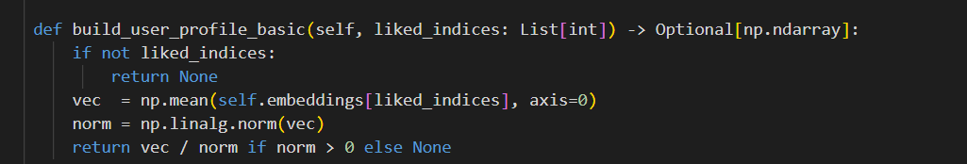

Figure 24 – build_user_profile_basic

Although this method of profile construction is fairly simple, it demonstrates decent effectiveness when there are few interactions and allows creating a user profile quickly. It becomes necessary at those moments when we don't have enough information about the user yet, for example, right after he logged into the service.
For better recommendation quality, it would be better to consider not only that a person interacts with a piece of content but to classify the nature of these interactions by giving them different weights. In particular, viewing, liking, and skipping content carry distinct semantically heavy meanings: if the former two are indicative of approval, the latter one signifies a lack of engagement and interest in interacting with such material. Hence, the usage of negative feedback enables the system not only to boost useful recommendations but to filter unwanted ones from reaching users.
In addition, it is possible to use an approach based on separation of user profile strategies. In this case, not only the interaction with the material but also the list of favorite pieces would be taken into account. In turn, the latter would acquire greater value because they represent stable interests on the part of a person.
The following algorithm (build_user_profile_weighted_from_events) can be used as an example of the implementation of such an idea. Different types of interactions are assigned numeric coefficients: «like» – 1.0 (a positive signal), «view» – 0.15 (weak/passive interest), «skip» – -0.35 (negative signal). Based on such weighting of different types of events, the product embeddings are aggregated, and the user preference vector is created.
In this way, the model becomes capable of capturing the user's interests based on positive and negative signals. Thus, the system becomes not only able to offer recommendations to the user, but also to avoid displaying objects that the user does not like, Figure 25.
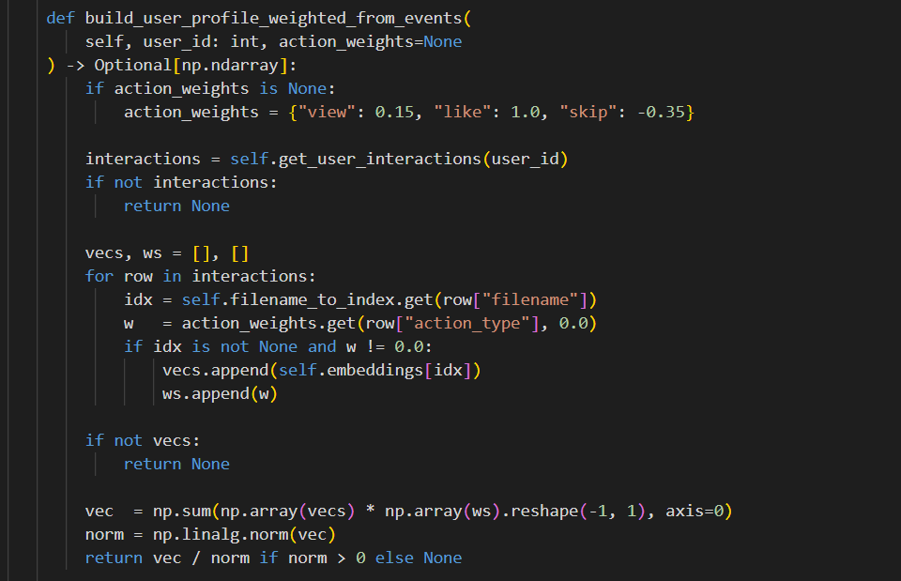

Figure 25 – build_user_profile_weigted_from_events

The method for generating a user profile using the combined strategy (build_user_profile_weighted_combined) includes a series of steps aimed at collecting information about user preferences from different sources. In particular, the resulting vector will be created as a weighted sum of the embedding vectors from the user’s history of interacting with items (browsing, liking, skipping) and a list of favorites. Here, the embedding vector obtained from the favorite items will have a greater weight (by default, 2.0), because putting an item on the favorite list indicates a more persistent and deliberate interest of the user compared to single actions like browsing.
During the calculations, all available embedding vectors are summed up with consideration of their weights, after which the vector of user preferences is created.
The obtained final vector is stored in the global_interest_vector field of the PostgreSQL users table as a row of the vector elements with a comma delimiter. Although this storage approach is inefficient from a performance perspective, it greatly simplifies the development of the prototype, making it easy to access user information.
Each time a user interacts with the application (views, likes, adds to favorites), the vector is recalculated. In this way, the system can update user data and quickly adjust recommendations according to changes in the user's preferences. The use of this approach ensures that there is a compromise between short-term decisions and long-term interests, improving the quality of personalized recommendations, Figure 26.

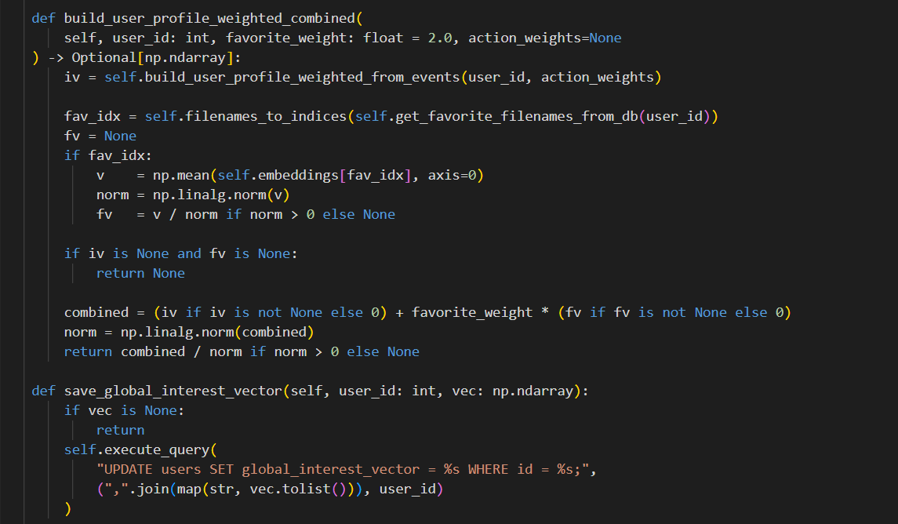

Figure 26 – build_user_profile_weight_combined

The creation of personalized recommendations (recommend_for_user) occurs through a number of consecutive stages. First, a user profile is generated: either it is retrieved from the database (if the rebuild_profile parameter is equal to True), or it is reconstructed using the user's current behavior in the system. This method helps incorporate both previous preferences of the user and new actions performed by user, Figure 27.

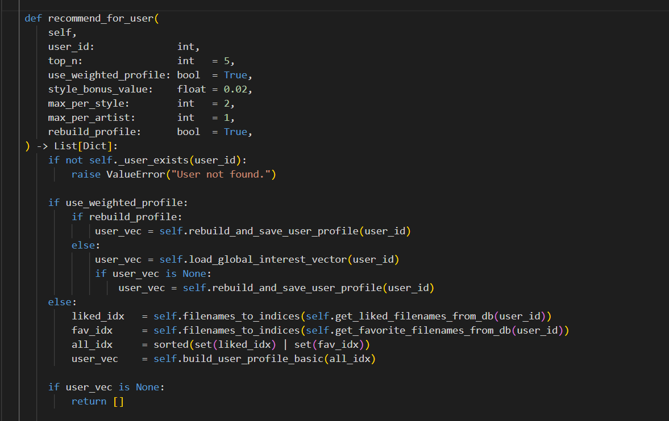

Figure 27 – recommend_for_user

Then, the cosine similarity between the user profile and the embeddings of all artworks in the collection is computed. These numbers represent the level of similarity of objects to the interests of the user and serve for the preliminary ranking of the recommendation list.
Finally, an additional refinement of the recommendations is carried out considering the artistic style. In case there are works among the recommendation outputs that are compatible with the user's taste, they receive additional bonuses in their ratings using the style bonus method.
Then novelty filters are applied: the works viewed by the user previously (liked or not) are filtered out of the recommendation list. This way we make sure that no familiar works will be recommended again to the user and thus increase the user experience.
The last stage of the process is applying the diversity filters (_apply_diversity_filters function). This way we limit the number of works of one particular style or genre within the final recommendation list. This is done to avoid the "filter bubble" problem and provide the user with a diverse range of artworks.
Along with personalization features, additional ways of using the application have been developed. In particular, a search function for works of art that look similar to each other has been realized. The algorithm is similar to the previous one – recommendations are generated by embedding one artwork without consideration of the user’s personal preferences. (recommend_by_artwork). In this case, the similarity is calculated based on the cosine of vectors, where the query vector is the embedding of the selected image, and the vectors from the database correspond to the embeddings of the other artworks. Thus, a user can find artworks that are visually similar to each other.
Another feature that has been implemented is a recommendation system based on the input image (recommend_by_image). In this use case, the user can select an arbitrary image and upload it. Then, the system generates the vector embedding of the image, which is calculated using the CLIP model. Next, this vector is compared with the vectors from the database, and the most relevant artworks are returned to the user.
In order to resolve the issue of the cold start, the system uses the principle of interaction with the initial user – "onboarding". The purpose of this process is fast acquisition of preliminary information about the preferences of the user prior to obtaining behavioral data.
The function get_onboarding_candidates provides for creating a list of art pieces suggested to the user as the first step. At the same time, the list should be created in such a way that it included images belonging to different styles and trends. In this manner, it would be possible to gather maximum information about the preferences of the user in spite of the fact that there will be limited options.
Using the list of selected pictures, a preliminary profile is created as a vector of aggregated embeddings of pictures liked by the user. Using the profile thus created, the process of generating personalized recommendations begins, Figure 28.

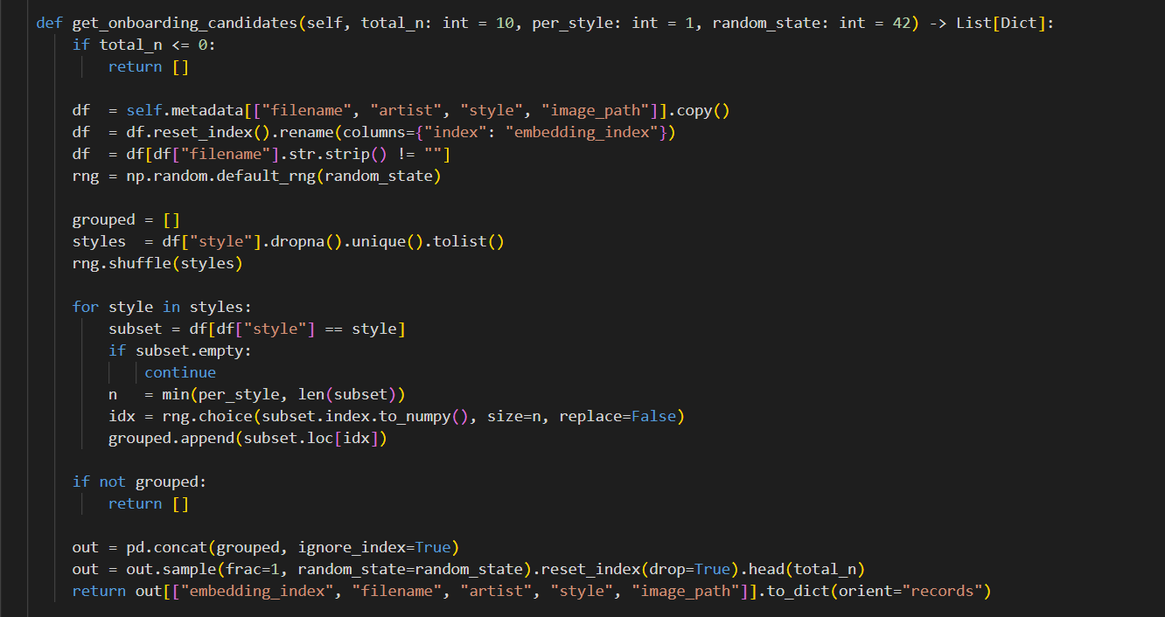
Figure 28 – get_onboarding_candidates

It should be noted that the described algorithm applies to the creation of content-based recommendation systems. During operation, the algorithm does not require any supplementary training of the model, thanks to the already pre-calculated image embeddings. This simplifies the entire structure of the system significantly and decreases computation expenses, which is particularly relevant in the context of graduation project implementation.
Due to the use of precomputed embeddings, it is possible to provide real-time recommendations, thus ensuring fast request handling. On the other hand, high-quality recommendations are provided thanks to the use of contemporary models of computer vision, like CLIP, able to consider both the visual and semantic similarities of the analyzed images.
Therefore, the selected approach ensures a proper balance between simplicity and effectiveness. In turn, recommendations will be made according to the visual properties of paintings and user preferences, making it an effective solution for the given task.

Backend implementation
For building the server side of the recommendation application, we decided to use FastAPI, a fast modern Python framework for building web applications and creating the REST API based on the standards of the ASGI (Asynchronous Server Gateway Interface). FastAPI is an optimal choice since high performance, data validation, and automatically created API documentation are necessary for the system.
FastAPI allows checking the correctness of the provided input and serialization of responses with the help of Pydantic. That is why we write less boilerplate code (and commit less errors), we know what we get from the service. Also, FastAPI creates versions of OpenAPI automatically and represents API in Swagger UI, which helps a lot while testing and debugging the app. The fast performance of FastAPI is ensured by Starlette (ASGI layer) and Uvicorn (the server). Thus, FastAPI may be compared to NodeJS and Go in terms of speed.
What does the server app look like? In the first module, we initialize FastAPI, and define the recommendation engine service. The MuseumRecommenderService object will be created only once at the very beginning of the application's launch and will be used by all handlers. Therefore, we do not "reinitialize" expensive processes such as embedding loading, normalization, and auxiliary data structures building. We just get everything ready-made and use it.
The interaction with the frontend is implemented via a set of REST API endpoints for different system use cases. They include registering and authorizing users, obtaining recommendations using various methods, storing user actions, interacting with the chosen art works, and on-boarding. All endpoints accept some input parameters, which are validated via Pydantic schemas, passed further to the app logic, and return the result in JSON format.
The validation of entered data relies on the «fail fast» rule, meaning you are able to exclude erroneous requests from further processing through the service. In order to validate data, data models are used; they include descriptions of the query structure, length limits of strings, allowed values, and other parameters required for checking the entered data by a user. The user actions can only be one of the predefined set of values, besides the lines are automatically cleared of unnecessary blanks. Thus, it is possible to avoid the occurrence of inconsistent data.
The errors of all API endpoints will be processed equally: if it comes to the business logic error (wrong input data, restrictions), the response will be given with status code 400 Bad Request, including description of the cause of the problem. If authentication fails, the code 401 Unauthorized will be sent. All the errors that are not expected by the application logic will be marked with the 500 Internal Server Error status code.
Passwords for user authentication are stored using secure hashing. The PBKDF2-HMAC-SHA256 algorithm is used with a unique salt and a large number of iterations, which prevents hacking by brute force. When logging in, passwords are verified using a secure hash comparison, which minimizes the risk of time attacks. The current service lacks the concept of tokens or sessions, as the service is designed for an external client that manages the state on its own, Figure 29.

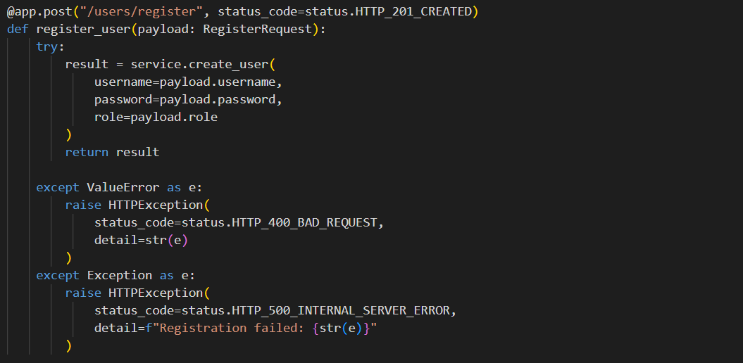

Figure 29 – «/user/register» endpoint

The interactions of users with artworks are logged using a special server endpoint that is responsible for user actions handling. It gets three key parameters for each interaction, namely, user ID, artwork ID, and interaction type (e.g., view, like, or skip).
Data validation occurs prior to saving the interaction. In particular, the existence of the user and corresponding object in the database is checked together with the accuracy of an interaction type passed by the request. Also, a special feature has been added for preventing duplicated actions, meaning that similar actions in a row will not be saved (e.g., multiple views for one object). Thus, it is possible to ensure the proper data validation and avoid distortions in the user profile formation.
After saving the user interaction, the user profile update process begins automatically. In particular, the aggregated vector of the user's preferences is updated based on new information about interaction. This ensures timely updates in a user's profile in order to provide relevant recommendations according to their needs and preferences, Figure 30.

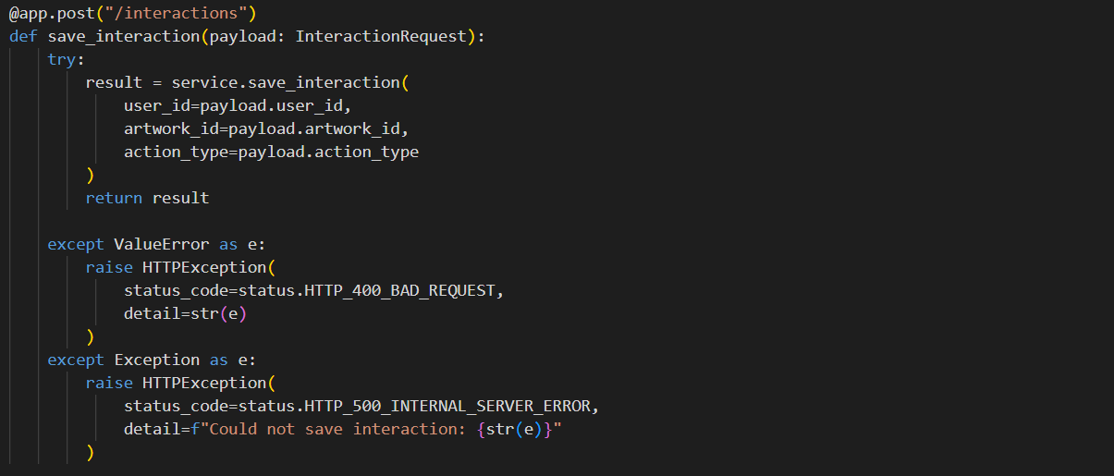

Figure 30. «/interactions» endpoint

The work with favorites takes place by separate endpoints for adding, removing, and getting favorites' list. In order not to get duplicates, a conflict resolution algorithm at the level of a database is implemented, thus idempotence is ensured and there is no need for any checking at the level of an application. The changes of favorites will influence the user's profile and, accordingly, will affect the recommendations.
A specific module can be implemented for the endpoint of the image uploading according to which recommendations will be made. The request must use the multipart/form-data content type. Once the file is received, the extension is verified, and after that, the file itself is checked via the Pillow library. The process takes place in a temporary directory, after which the file is deleted from the server.
Psycopg2 is used for interacting with the PostgreSQL database. All procedures are performed via parameterized queries, making SQL injection impossible. Connections are handled through context managers to guarantee closing of connection and committing transactions. The result is formatted into Python dictionaries.
A unified API interface provides for all the steps of a user's interaction with the services – from signing up and onboarding to getting recommendations by different means, including favorites management.
This can be used for constructing a whole backend system that will include not only the database and user interaction methods but also a recommendation algorithm.

Table11 – REST API Endpoints for Functional Modules

Endpoint | Method | Purpose
/ | GET | API health check
/users/register | POST | User registration
/users/login | POST | User authentication
/onboarding/candidates | GET | Retrieve images for onboarding
/onboarding/submit | POST | Submit selected images
/recommend/for-user | POST | Generate personalized recommendations
/recommend/by-artwork | POST | Find similar artworks
/recommend/by-image | POST | Generate recommendations from uploaded image
/interactions | POST | Store user interaction
/favorites/add | POST | Add artwork to favorites
/favorites/remove | POST | Remove artwork from favorites
/favorites/{user_id} | GET | Retrieve favorite artworks

In conclusion, the server-side implementation was completed in the form of a complete REST API that receives requests, manipulates the database, and generates recommendations. Implementation using the framework FastAPI proved to be effective, as we were able to develop a reliable and easily maintainable application that met our requirements.

User Interface Implementation
The user interface for museum recommendation software is made using Streamlit, a web application toolkit built in Python that does not require any HTML, CSS, or JavaScript knowledge from the programmer. The selection of this particular framework depends on the nature of the project since Streamlit offers very fast integration with the tech stack of the project (NumPy, Pillow, Requests), thus making the creation of the prototype much faster. The user interface consists of a multi-page application with a side navigation menu, but all pages are located in one and the same file, Figure 31.

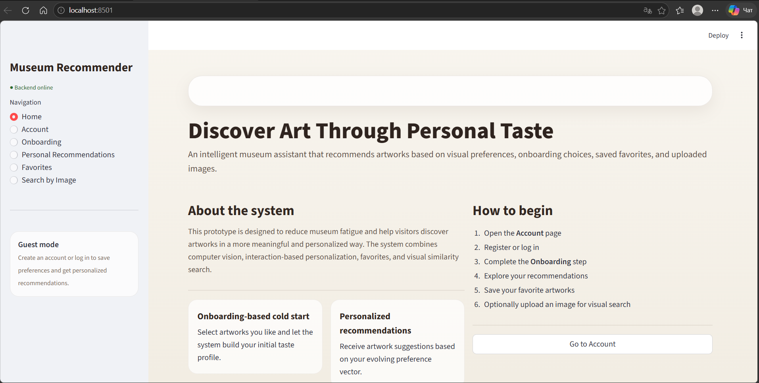

Figure 31 – Home Page
One of the most important elements of the architecture of the interface is the method of managing the states using the object st.session_state, which enables saving information between renderings of the application. It is crucial due to the fact that each interaction with the application causes its restart. The initialisation of the states is carried out by the function init_session_state(), which determines the values of the initial parameters required for the operation of the application.
The interaction with the server-side is performed by means of HTTP requests through REST API to ensure proper separation between frontend and backend components. In order to perform the described interaction, universal functions for sending request to the server have been developed. They incorporate the entire logic related to working with the network including performing a request to it, transfer of parameters, and analysis of the server response. Thus, it becomes possible to use only one strategy while using all API endpoints of the system.
Much attention is given to centralized error handling, which enables correct reaction on different kinds of errors such as absence of connection to the server, exceeding the timeout, as well as receiving errors from API. Thus, the user receives a proper notification about the errors encountered, and it becomes possible to ensure reliable work of the system regardless of network issues.
Artwork card is the key visual component of the user interface that forms the basis of content representation in the system. The card consists of the artwork picture and relevant information, such as the artist's name and his artistic direction, enabling users to easily browse through the offered material. Besides, the card includes controls, like the 'add to favorites' button, thus providing the opportunity for interaction with the system.
Cards have high reusability and can be used in different application cases. Depending on the situation, they can be expanded with various elements, such as a similarity indicator in case of recommendations or selection options in the onboarding case. As a result, the flexibility and reuse of this component help simplify the development process for the interface.
The gallery of artworks is built upon individual cards and represents an adaptive grid of pictures. It ensures effective use of the screen and comfortable viewing of many items at once. The gallery is widely used across all scenarios of the system's operation, starting from preference selection during onboarding and ending with recommendation display and item choice.
User interaction with the system begins with an authentication page that provides access to personalized application features. On this page, registration and login forms are implemented, allowing both new and existing users to start working with the system, Figure 32 and Figure 33. Before sending the data, their preliminary verification is performed on the client side, including checking whether the fields are full, the length of the login and password, as well as the correctness of the input. This reduces the number of incorrect requests to the server and provides a faster interface response. After successful authentication, user data such as ID and name are stored in the application state, which allows you to maintain an active session and provide access to personalized system features.

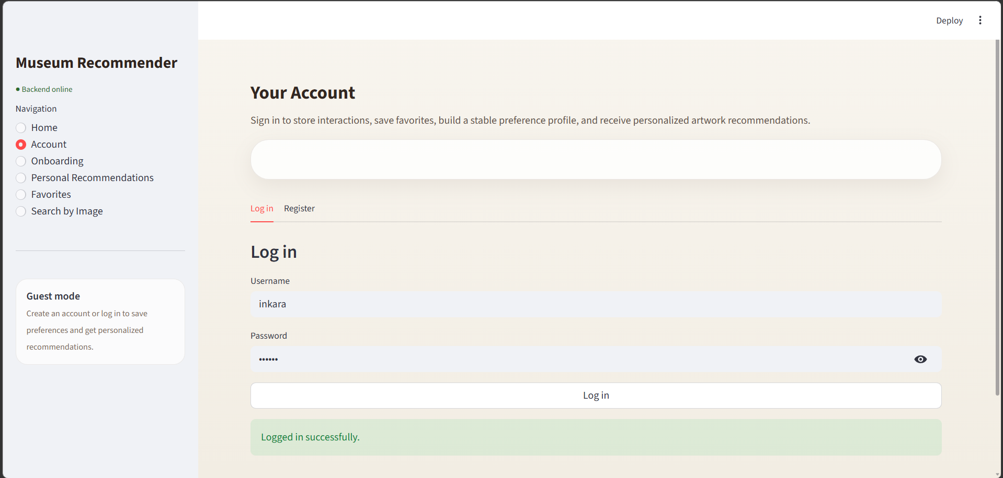

Figure 32 – Account Page: Log in

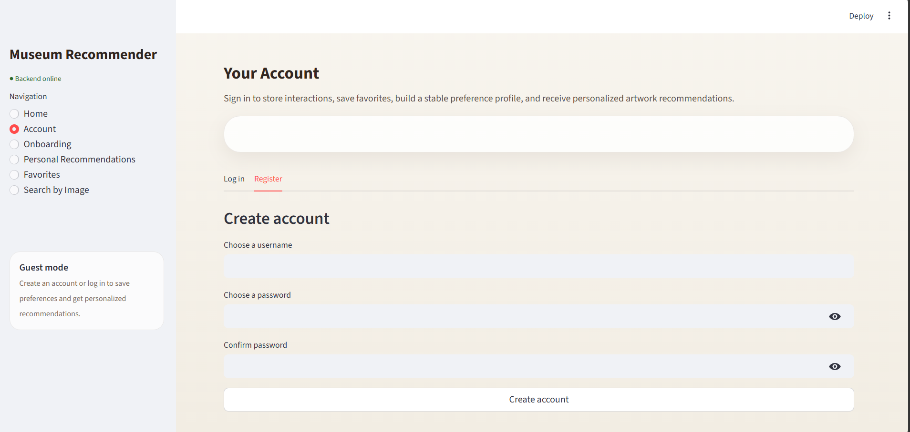

Figure 33 – Account Page: Create account

After logging in, the user proceeds to the next stage — onboarding, which is implemented to solve the problem of cold start. Since the system does not have information about the user's preferences at the initial stage, they are asked to select their favorite works of art from a specially created gallery. This set includes images related to various artistic styles, which allows you to get a more representative idea of the user's visual preferences.
Based on the selected works, an initial user profile is formed, which is an aggregated embedding vector. This profile is used to generate the first personalized recommendations, which allows the system to immediately offer relevant content, Figure 34. Thus, the onboarding stage ensures a smooth transition from data absence to personalized interaction, improving the quality of the user experience from the first steps of working with the application.

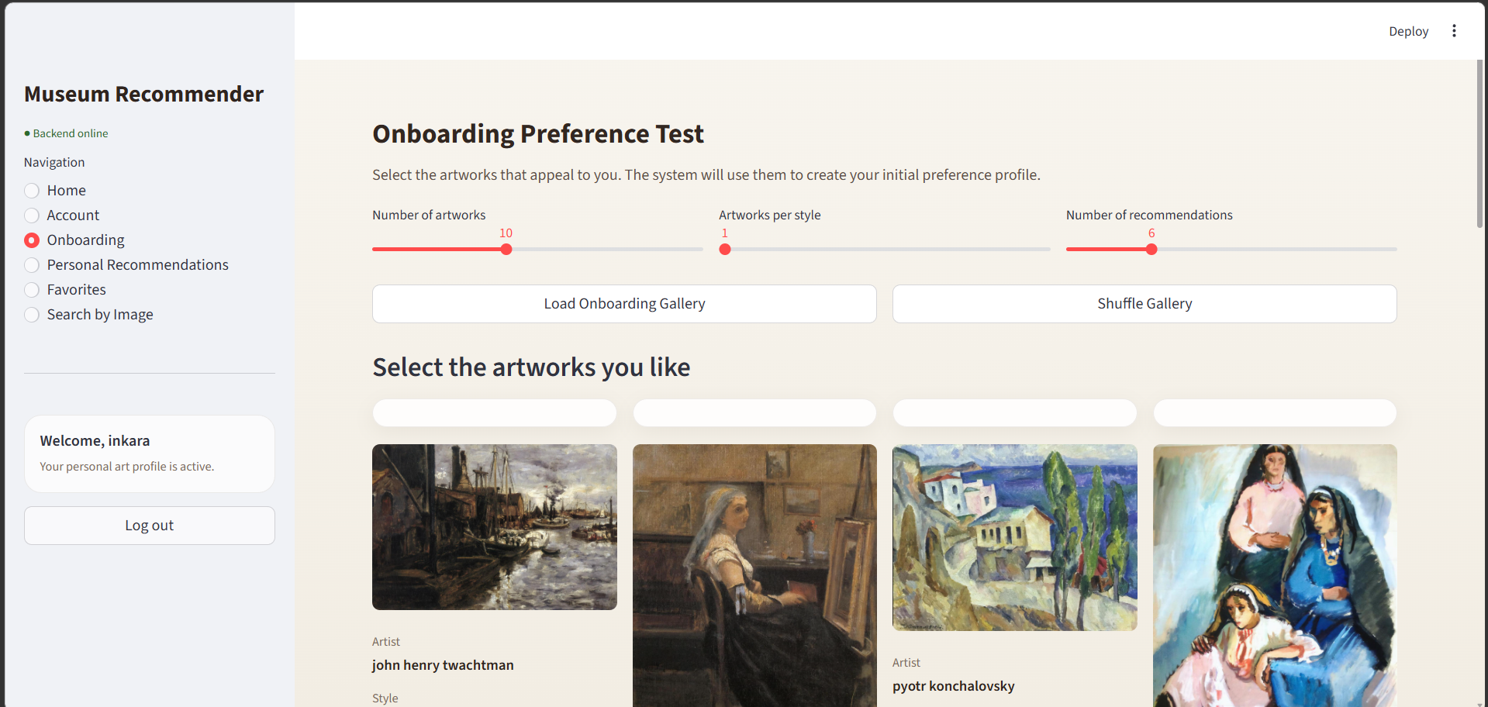

Figure 34 – Onboarding Page

Once the user passes the stage of onboarding, he or she gains access to the personal recommendations page that plays an important role in the whole system. This page provides the convenient user interface that allows to manage recommendation generation process flexibly without being involved in understanding internal algorithms. Several modes of action are suggested to the user, with each mode setting the proportion between visual similarity of artworks and diversity of the content provided to the user.
The choice of mode impacts internal parameters of the recommendation system, including the extent of consideration of similarities between embeddings, limitations regarding number of works of one style or artist, as well as applying the styles bonus parameter. It means that the user is able to prioritize either more similar artworks or, on the contrary, diversify recommendations. Another option that can be used here is a weighted preference profile, which is built based on the user’s behavior (viewing, liking, skipping, and favoriting artwork), Figure 35.

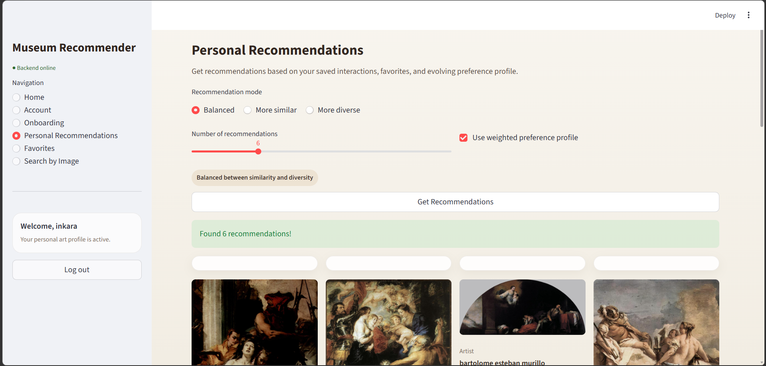

Figure 35 – Personal Recommendation Page: Setting.

All recommendations created by the system are demonstrated using an art gallery interface, with every recommendation card containing an image and some text describing it, Figure 36. The user can work with any card in order to save the recommendations to favorites, see them in a more detailed format, or keep searching via recommendations. In addition to giving the user a convenient interface to visualize the results, this implementation ensures a process of continuous personalization, where user actions impact the results of future recommendations.

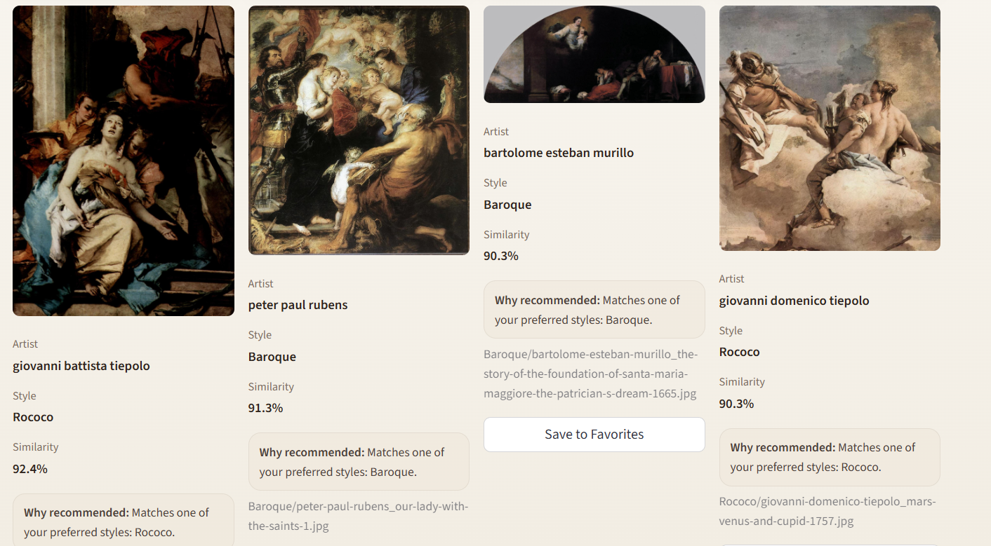

Figure 36 – Personal Recommendation Page: Result

Besides, there is also the possibility of working with favorites, where the user can add his/her favorite pieces of art and create his/her own personal gallery. Such function serves not only as another means of convenience, but also serves as additional information on the preferences of the user, as adding something to favorites implies that the interest towards it is greater than that of a one-time interaction.
While opening the favorites tab, the information is loaded from the server through the specific API endpoint and stored in the local application state. In order to make the process quicker, a client-side cache feature was implemented, thus making it unnecessary to load the list of favorites from the server every time when the page is loaded, making everything much faster and easier for the user.
The interface of the favorites page is done in the form of a gallery, just like the other parts of the application, Figure 37. This way, it guarantees consistency within the application. The user is able to see the artworks that have been saved, as well as delete those which he does not need any more. What is more, the synchronization of the local state and the server makes the interface seem very dynamic.

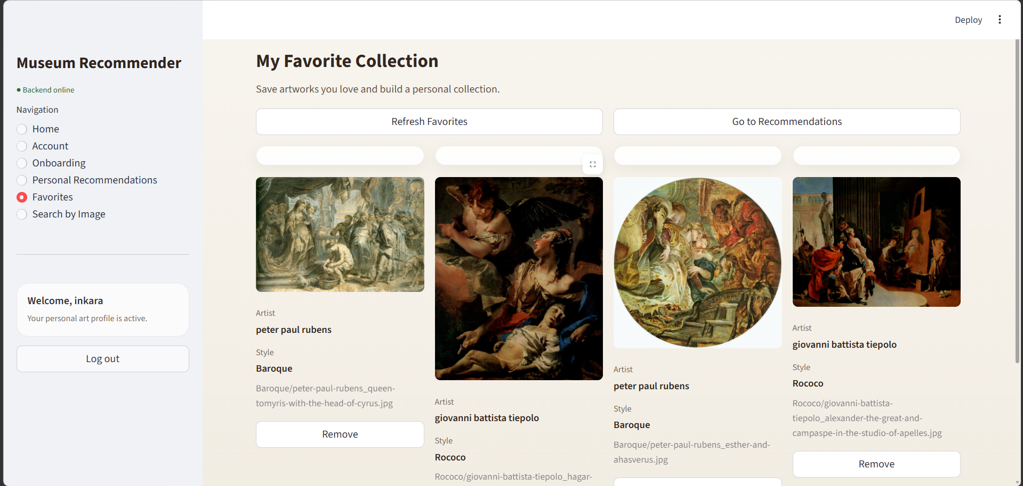

Figure 37 – My Favorite Collection Page

The other use case of the application is image search, Figure 38. It helps you increase the functionality of the app even further. In this case, the user needs to upload an image he/she has chosen, and then the app will analyze it and output the most similar works of art that exist in the database. With the help of such an option, the interaction with the system becomes much more flexible, as now the user is not limited in choosing among the artworks offered by the app but can choose his/her own image from outside.
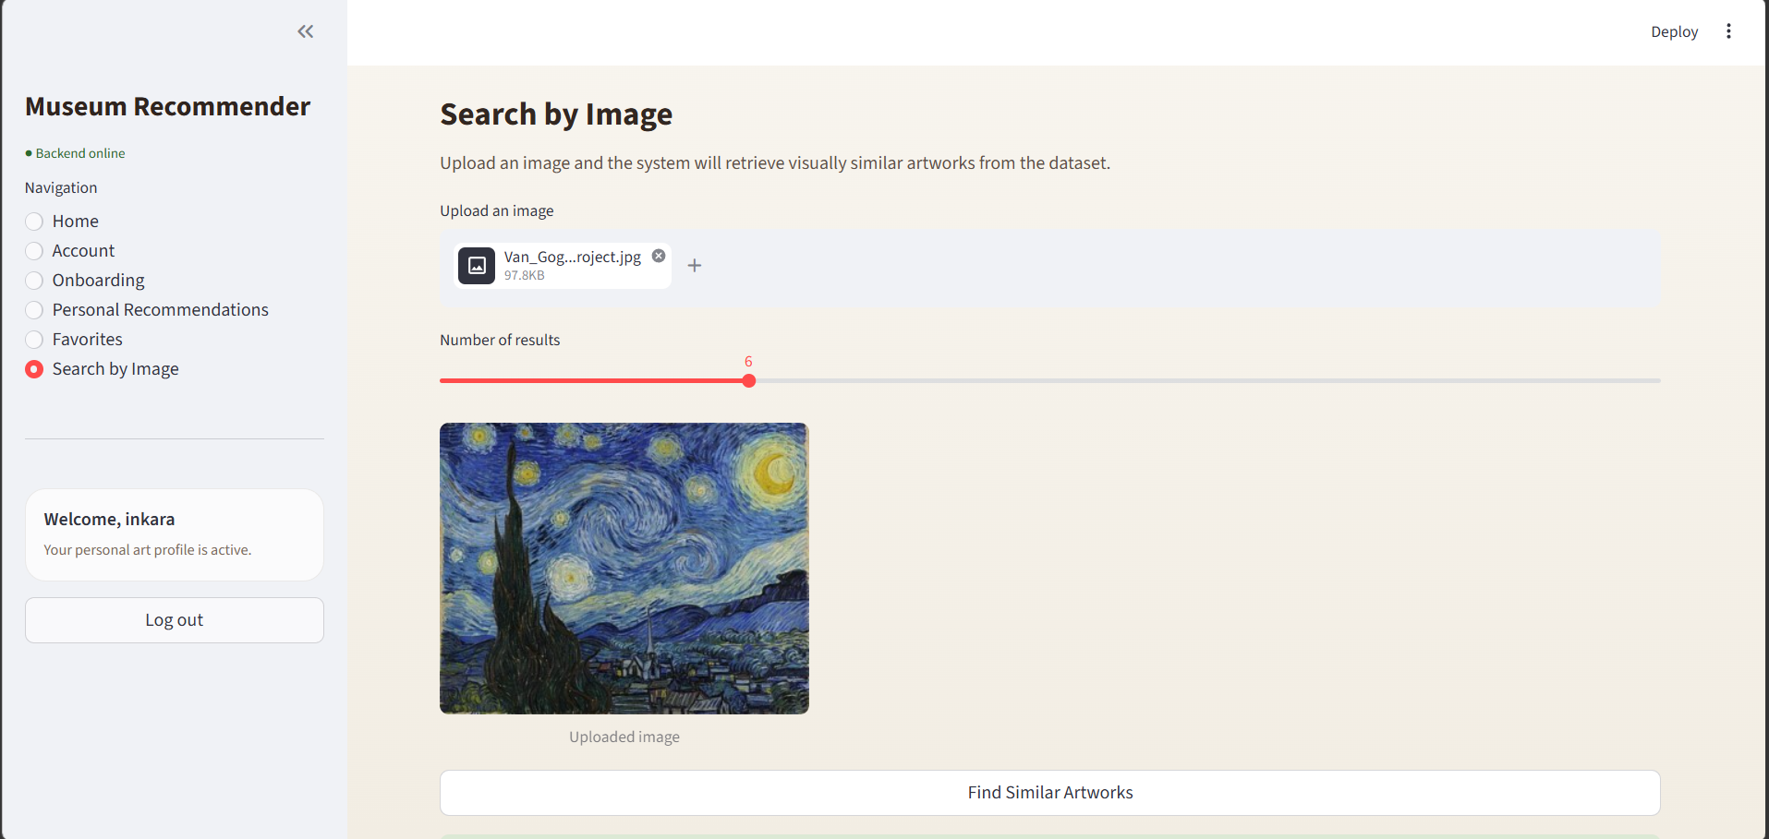

Figure 38 – Search by Image Page: upload an image

Technically, an uploaded image is processed with the help of the CLIP model, and then its embedding is created in real-time mode. After that, the embedding is compared with the pre-computed embeddings of works of art that are saved in the database, and cosine similarity is used as a metric in this process.
The results are displayed to the user as a gallery, similar to other operating modes of the system, which ensures uniformity of the interface and simplifies perception, Figure 39. The user can interact with the found objects by adding them to favorites or continuing the research through subsequent recommendations.

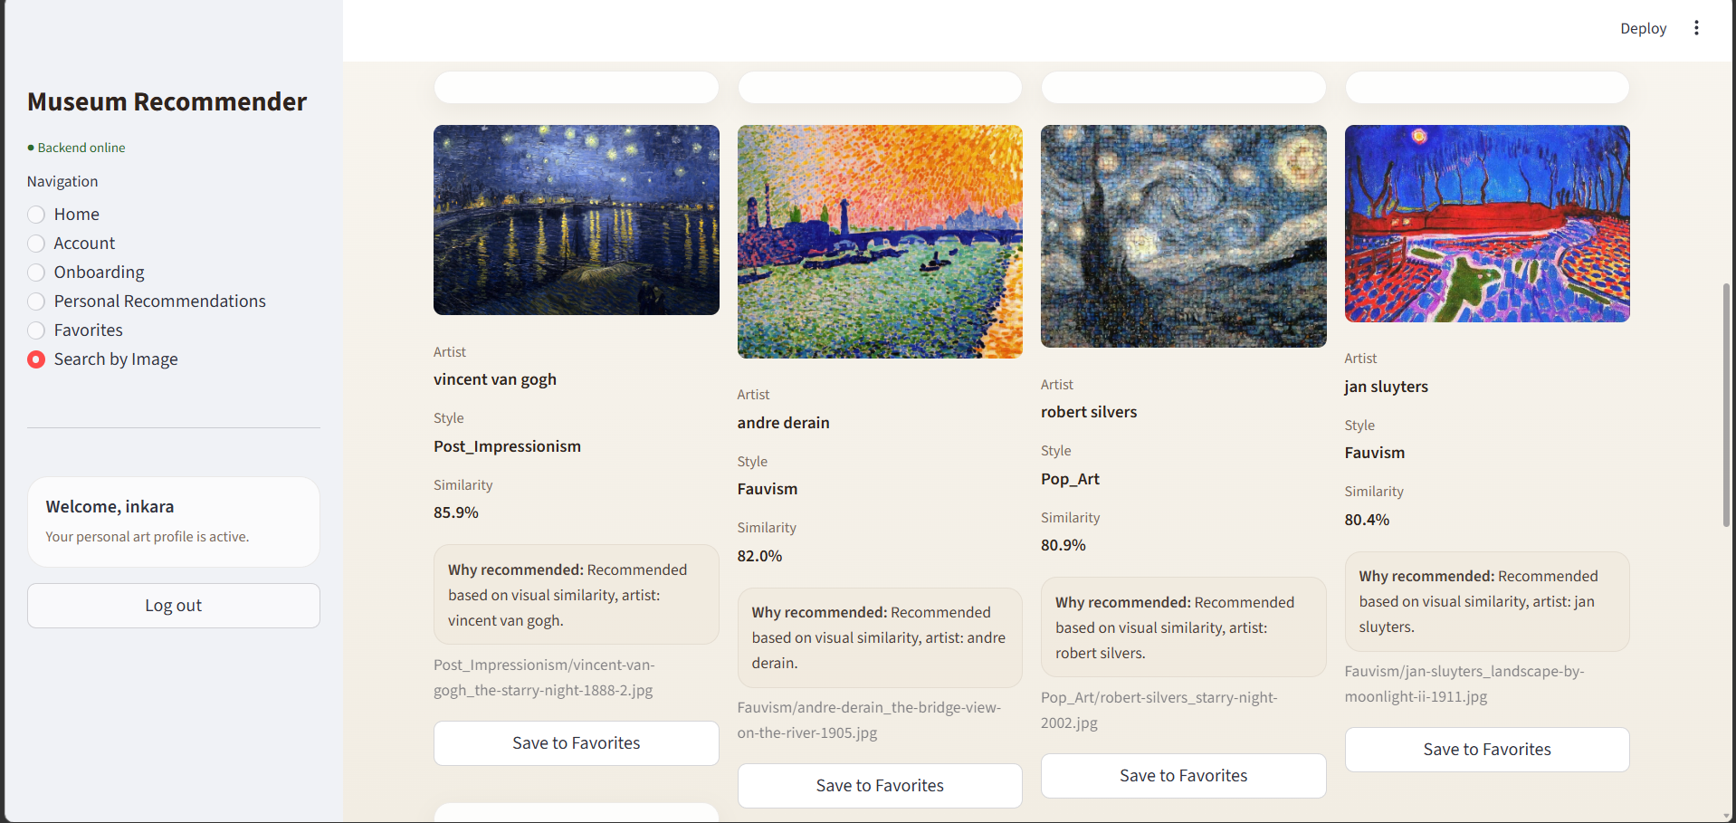

Figure 39 – Search by Image Page: result

Navigation within the application takes place using the sidebar, which is an integral part of the interface that can be accessed by the user at any stage of using the system. The sidebar includes navigation elements, namely, links to the sections of the application, which are the main functional components of the program, namely, the main page, authentication, registration, recommendations, favorites, and picture search. Furthermore, the sidebar includes data about the current user, which is represented by his name and status, as well as the status of the backend. Thus, you will be able to track the status of the software interface and know whether the application works properly.
Interaction is improved with the help of synchronization with the current state of the application interface, meaning that when selecting a certain section of the program, the corresponding changes will be shown instantly, while changes in user status, for instance, login or logout, will also be reflected instantly.
Hence, the user interface that has been created is a fully logical application that is fully integrated into the backend with the help of the REST API. The entire user path from registration and onboarding to recommendation and visual search and creation of the personal gallery has been covered. All due to the fact that the user interface was designed in a very consistent manner that makes it useful and ready to be used further.

Conclusion

In the process of writing the thesis, a recommendation system for museum exhibits was created, with the intention of raising the quality of experience provided to the user and simplifying the interaction with the cultural content in question. The relevance of the topic lies in the current processes of digital transformation of the museum sector, which includes not only the introduction of new ways of presenting exhibitions but also personalizing them and addressing the specific interests of a particular viewer.
In the first chapter, recent trends in the development of digital technologies in the museum sector were analyzed. Furthermore, the comparison of the existing services for creating a better experience in museums, such as Google Arts & Culture and Smartify, was provided. The analysis revealed that although the possibilities provided by the above-mentioned technologies are quite wide, the problem of personalization of the content provided according to the preferences of a particular user still remains topical and poorly solved.
In the second chapter, the architecture of the system was created, which consisted of selecting and pre-processing the dataset, constructing vector representations of images using a multimodal CLIP model, as well as designing a database and the client-server architecture of the application. Particular importance was attached to forming a balanced dataset, representative of various styles, epochs, and genres, as well as applying the metric of cosine similarity to measure the closeness of artistic works in embedding space.
The implementation of the software component of the system was carried out in the third chapter. An algorithm of recommendation based on a combined analysis of visual similarity and interaction history was proposed. The server-side is implemented using FastAPI, while the user interface is implemented using Streamlit. Scenarios of work include personalized recommendations, finding visually similar artworks, working with user evaluations and likes, as well as an onboarding process to address the cold start problem.
Conclusions drawn from the study results:
The proposed system shows high efficiency in applying machine learning and computer vision techniques within the scope of a museum application. The use of the CLIP model enables the consideration of both visual and semantic features of artworks, thus improving the recommendation quality compared to methods that rely exclusively on metadata. The content-based nature of the proposed approach guarantees a robust system performance even in situations where there is a lack of user data, which is highly relevant for museums that experience uncertain visitation rates. The onboarding procedure with the help of a questionnaire efficiently deals with the cold start problem by helping to build an initial user profile in the absence of interaction history.
Recommendations for future system improvements:
One way forward would be a move towards hybrid recommendation systems using both content-based and collaborative approaches, as they consider not only attributes of the work, but also behavior patterns of similar users. For this to happen, it would be necessary to collect enough data about the user, but this would substantially improve the quality of recommendations.
Another important avenue would be reinforcement learning from human feedback, where the recommendation system adjusts its algorithm by taking into account feedback signals explicitly and implicitly provided by the user – viewing time, ratings, and user interaction with an exhibit card.
As for technical aspects, there is an opportunity to use another frontend stack, such as React, to build a proper mobile application, which could be used right inside the museum rooms. Integration with geolocation will make it possible to provide users with context recommendations, meaning that tips about the exhibit that is right now near them will appear on the screen.
Also, integration of the project with APIs of other museums, like Europeana, The Rijksmuseum API, and The Metropolitan Museum of Art Collection API is interesting since this way we would significantly increase the size of the dataset without manually generating new data.
The practical value of this study is determined by the fact that the proposed system can become the foundation for creating intelligent assistants and digital platforms that will be useful in different cultural organizations. In other words, the project architecture provides us with the ability to expand the project step by step from deploying a system in one museum to a cloud platform with a huge amount of different exhibits from all around the world.
In this way, all of the set goals and objectives were fulfilled in the process of work. The created recommendation system for museum exhibits can be considered a fully realized project, which proves the effectiveness and usefulness of modern artificial intelligence technologies in the area of culture and digital heritage. These results can be implemented not only in scientific research but also in practical projects.

List of References

- Zavattaro C. et al. Visitor Characteristics and Museum Fatigue: A Case Study at the ETRU Museum in Rome. – 2026.
- Museum fatigue and visitor behavior // ScienceDirect. – 2025.
- Lei L. AI Technology for Immersive Museum Experience // Scientific Reports. – 2025.
- Role of Digital Technologies in Enhancing Museum Interaction and Visitor Experience. – 2025.
- Casillo M. et al. Context-Aware Recommender System-Based Framework for Improving Cultural Experiences // User Modeling and User-Adapted Interaction. – 2025.
- Kim E. Artwork Recommendations Based on User Preferences // ACM. – 2024.
- Yilma B. A. et al. ArtEx: Interactive Visual Art Recommendation System. – 2025.
- Zhao X. et al. Deep Learning-Based Recommender Systems: A Survey. – 2024.
- Chen Y. Personalized Recommendation Systems Using Content-Based Filtering. – 2025.
- Ricci F., Rokach L., Shapira B. Recommender Systems Handbook. – Springer, 2022.
- Aggarwal C. Recommender Systems: The Textbook. – 2023.
- Gómez-Uribe C. A., Hunt N. The Netflix Recommender System: Algorithms, Business Value, and Innovation. – 2021.
- Covington P., Adams J., Sargin E. Deep Neural Networks for YouTube Recommendations. – 2020.
- Nguyen T. T. et al. Exploring the Filter Bubble: The Effect of Using Recommender Systems on Content Diversity. – 2022.
- Pariser E. The Filter Bubble: What the Internet Is Hiding from You. – 2011.
- Zhang W. et al. Cold-Start Recommendation towards the Era of Large Language Models. – 2025.
- Marty P. F. Museum Informatics and User Experience in the Digital Era. – 2021.
- Damala A. et al. Personalization in Cultural Heritage Applications. – 2022.
- Villaespesa E. Data-Driven Museums and AI Applications. – 2023.
- Radford A. et al. Learning Transferable Visual Models From Natural Language Supervision. – 2021.
- Li S. et al. On CLIP Image Embeddings. – 2024.
- Kang R. et al. Is CLIP Ideal? – 2025.
- Schall K. Improving CLIP-Based Image Retrieval Systems. – 2025.
- Steck H. Is Cosine Similarity Really About Similarity? – 2024.
- Gao T. et al. SimCSE: Simple Contrastive Learning of Sentence Embeddings. – 2023.
- Google Arts & Culture [Electronic resource]. – URL: https://artsandculture.google.com/ – Accessed: 20.04.2026.
- Metropolitan Museum of Art [Electronic resource]. – URL: https://www.metmuseum.org/ – Accessed: 20.04.2026.
- Rijksmuseum [Electronic resource]. – URL: https://www.rijksmuseum.nl/ – Accessed: 20.04.2026.
- Rijksmuseum API Documentation [Electronic resource]. – URL: https://data.rijksmuseum.nl/docs/search – Accessed: 20.04.2026.
- OpenAI. CLIP Repository [Electronic resource]. – URL: https://github.com/openai/CLIP.git – Accessed: 20.04.26

Appendix

Loading and Normalizing Image Embeddings. Indexing works of art by file name

def __init__(self, embeddings_path: str, metadata_path: str, model_name: str = "ViT-B/32"):
print("Loading data...")

self.embeddings = np.load(embeddings_path).astype(np.float32)
self.metadata = pd.read_csv(metadata_path)

self.metadata.columns = [c.strip().lower() for c in self.metadata.columns]

if "filenames" in self.metadata.columns and "filename" not in self.metadata.columns:
self.metadata.rename(columns={"filenames": "filename"}, inplace=True)

for col in ["filename", "artist", "style"]:
if col not in self.metadata.columns:
raise ValueError(f"Column '{col}' not found in metadata")

self.metadata["filename"] = self.metadata["filename"].fillna("").astype(str)
self.metadata["artist"] = self.metadata["artist"].fillna("Unknown").astype(str)
self.metadata["style"] = self.metadata["style"].fillna("Unknown").astype(str)
self.metadata["image_path"] = self.metadata.get("image_path", pd.Series("")).fillna("").astype(str)

if len(self.embeddings) != len(self.metadata):
raise ValueError(
f"Embeddings ({len(self.embeddings)}) != metadata rows ({len(self.metadata)})"
)

norms = np.linalg.norm(self.embeddings, axis=1, keepdims=True)
norms = np.where(norms == 0, 1.0, norms)
self.embeddings = self.embeddings / norms

self.filename_to_index: Dict[str, int] = {
row["filename"]: idx
for idx, row in self.metadata.iterrows()
if row["filename"].strip()
}
print("Caching artwork IDs from database...")
self._filename_to_artwork_id: Dict[str, int] = self._load_filename_to_artwork_id()
print(f" Cached {len(self._filename_to_artwork_id)} artwork IDs")

self.device = "cuda" if torch.cuda.is_available() else "cpu"
print("Device:", self.device.upper())
self.model, self.preprocess = clip.load(model_name, device=self.device)

print(f"Embeddings: {self.embeddings.shape}")
print(f"Metadata: {self.metadata.shape}")

def get_connection(self):
return psycopg2.connect(**DB_CONFIG)

def execute_query(self, query: str, params=None):
with self.get_connection() as conn:
with conn.cursor() as cur:
cur.execute(query, params or ())
conn.commit()

def fetch_all(self, query: str, params=None) -> List[Dict]:
with self.get_connection() as conn:
with conn.cursor() as cur:
cur.execute(query, params or ())
cols = [d[0] for d in cur.description]
return [dict(zip(cols, row)) for row in cur.fetchall()]

def fetch_one(self, query: str, params=None) -> Optional[Dict]:
with self.get_connection() as conn:
with conn.cursor() as cur:
cur.execute(query, params or ())
row = cur.fetchone()
if row is None:
return None
cols = [d[0] for d in cur.description]
return dict(zip(cols, row))

